**Decision Tree:**

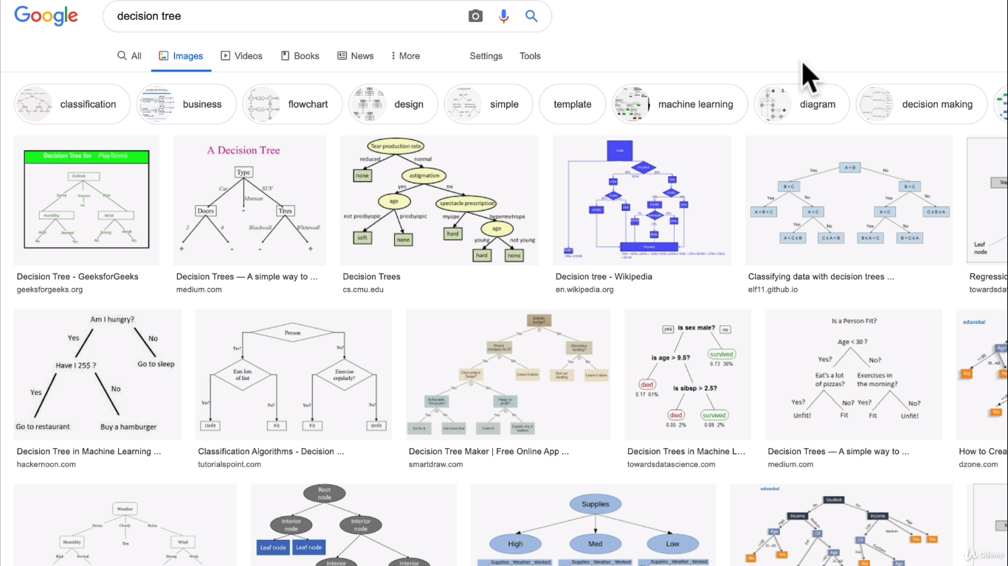

**Classification Machine learning model :**

**Within Classification model should you use ensemble or linear svc model?**

**Linear SVC model:**

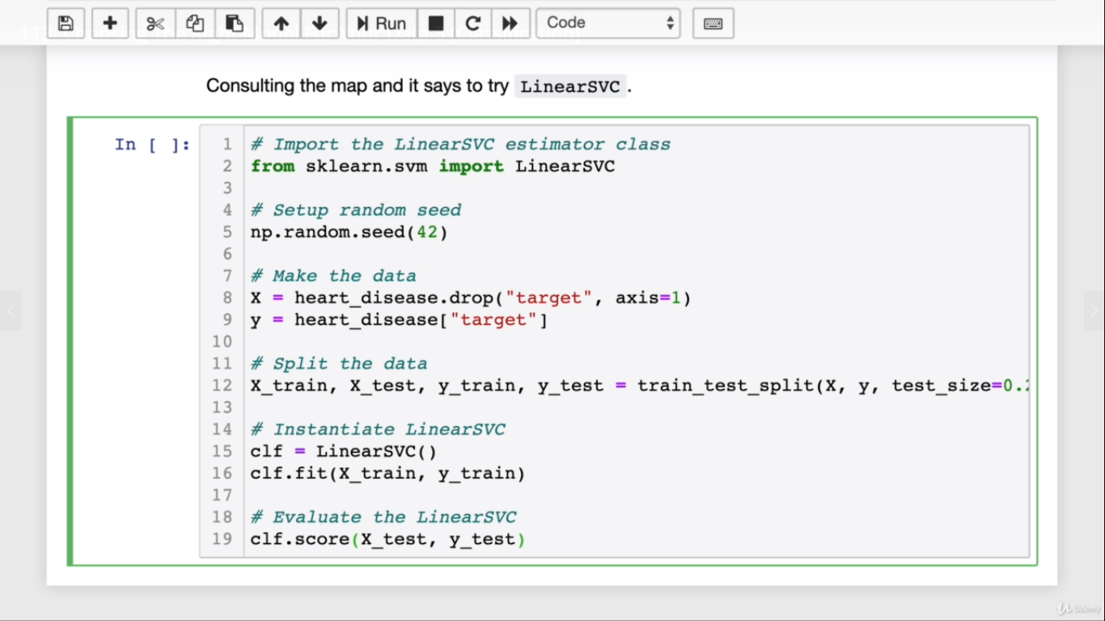

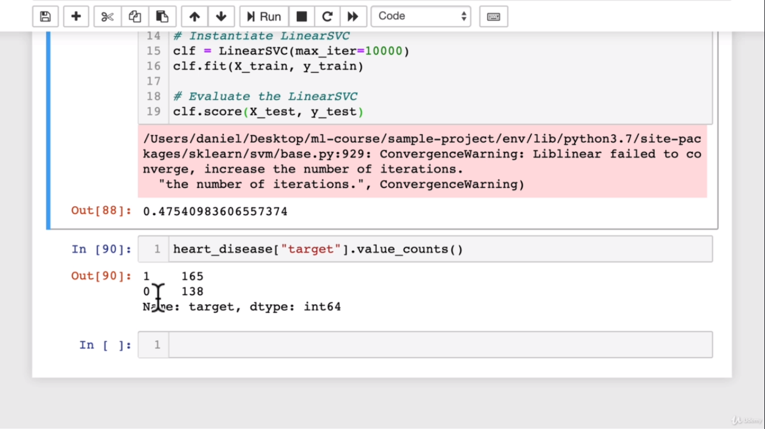

**It is a classic binary classification model and see belwo to count the records**

heart_disease[“target”].value_Counts()

**Since the score is less let’s try ensemble methods**

**Randomforestclassifer model:**

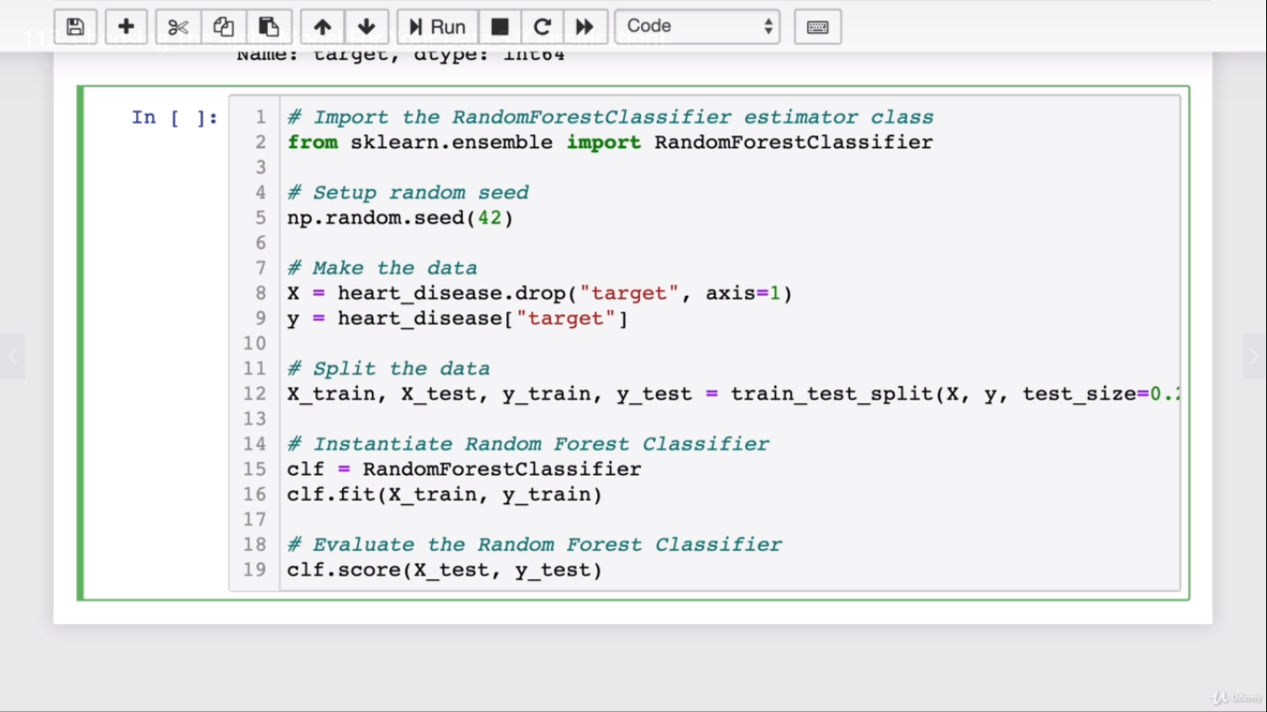

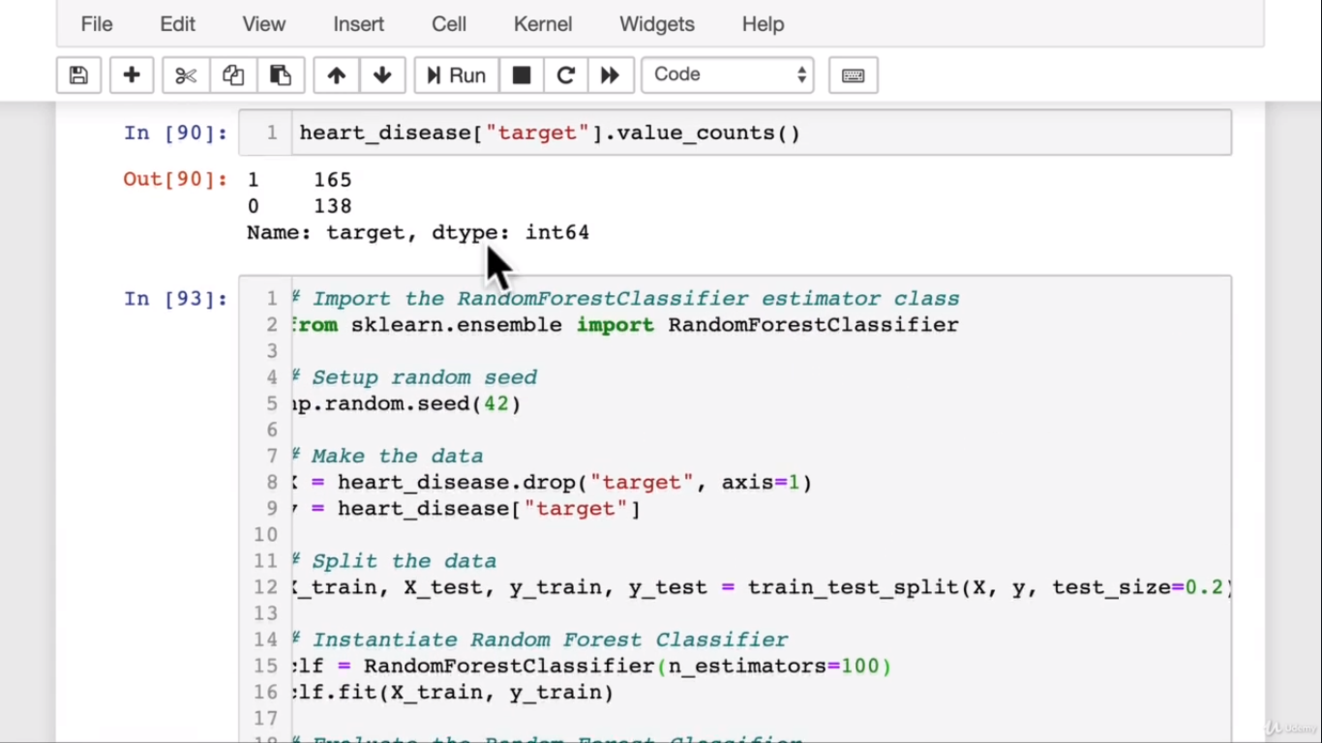

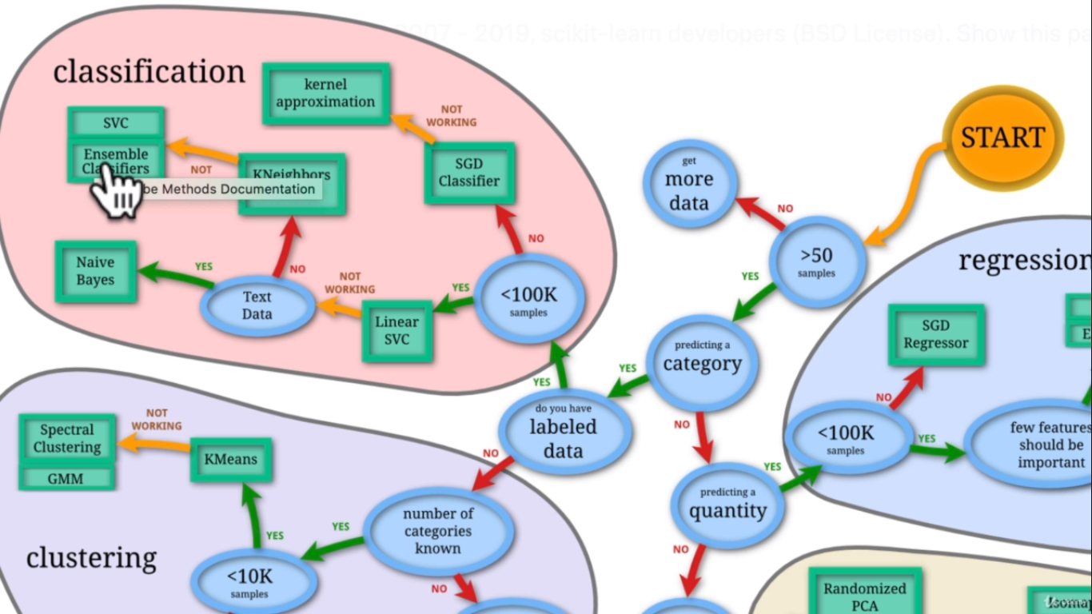

**Note:**

* If you have structured data use ensemble methods
* If you have unstructured data use deep learning or transfer learning

**Make predictions with our model:**

**There are 2 ways to make prediction:**

1. Predict()
2. Predict_proba()

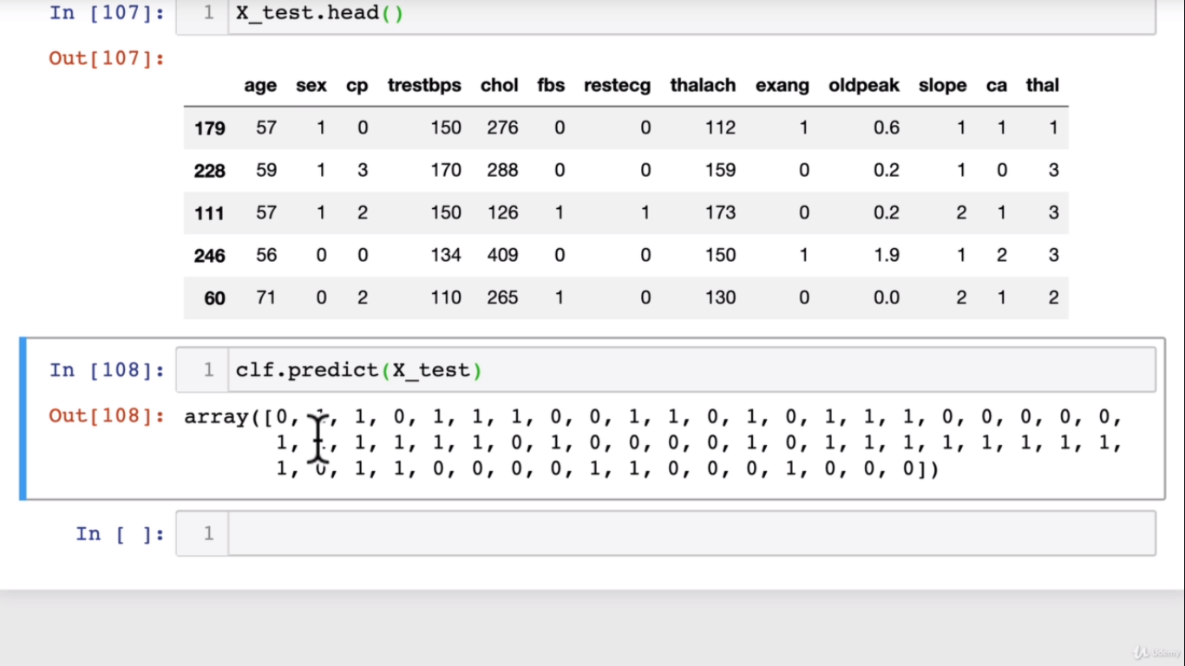

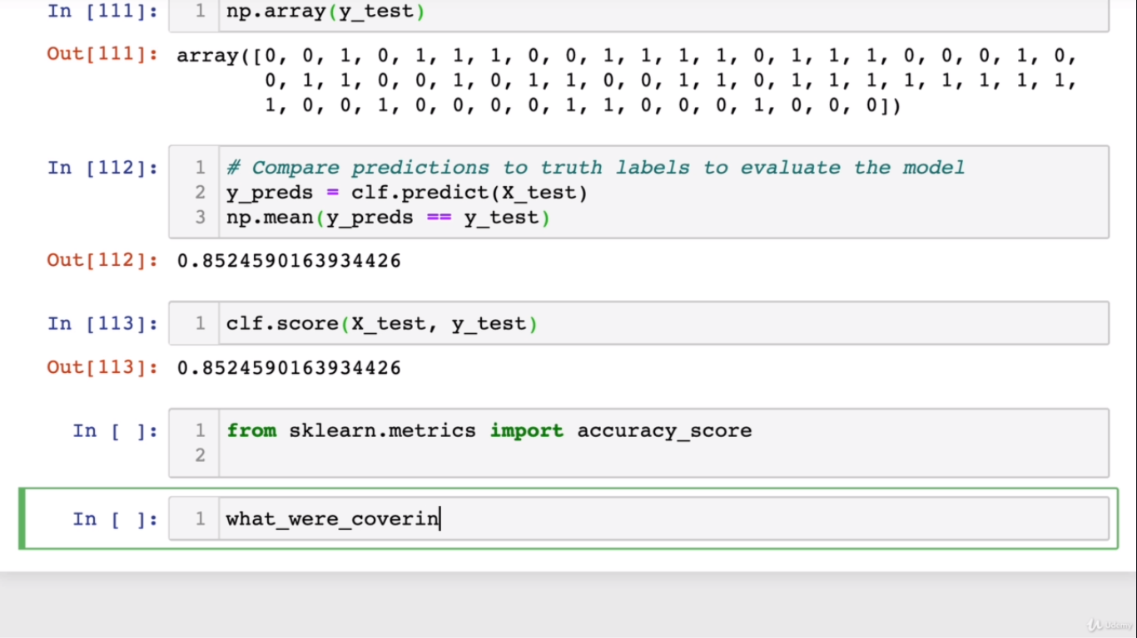

**We are testing the accuracy**

**Using sklearn as well**

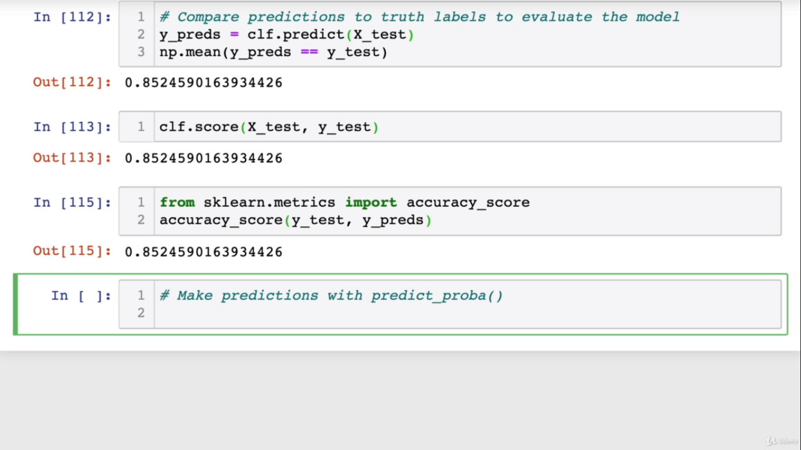

**Predict_proba() function:**

**This returns the probability of the result .**

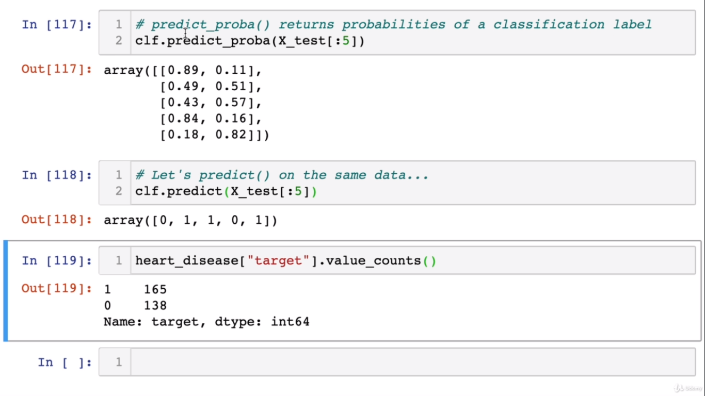

/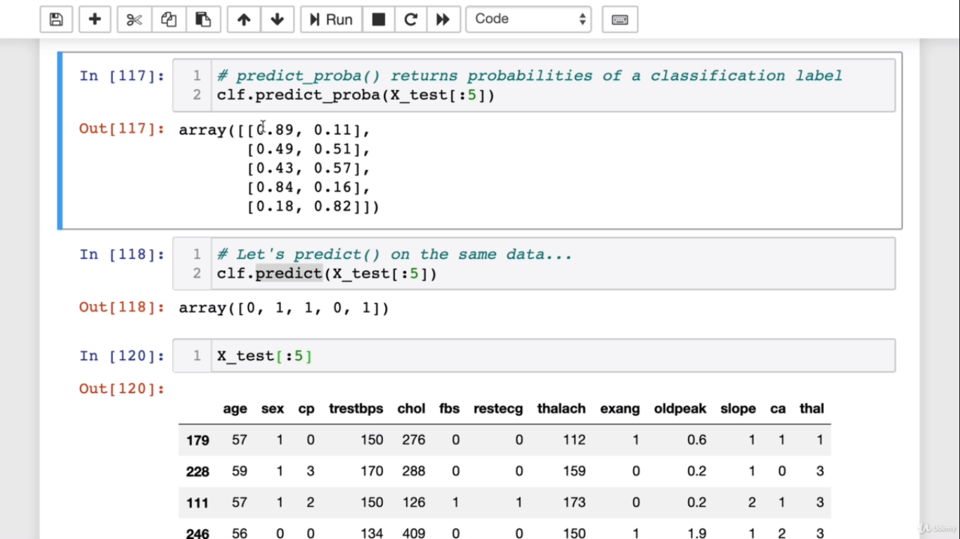

Both of the above are used for predictions for classification model:

**Now how to predict for regression model:**

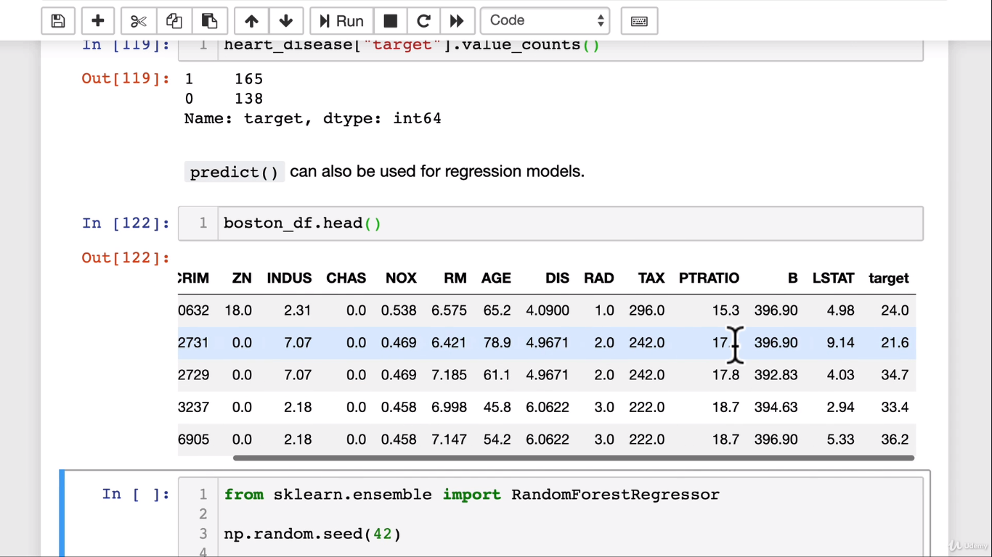

**CODE:**

from sklearn.ensemble import RandomForestRegressor

np.random.seed(42)

#create the data

X = boston_df.drop(“target”, axis = 1)

Y = boston_df[“target”]

**#split the training and testing set**

X_test,X_train,Y_test,Y_train = train_test_split(X,Y,test_size=0.2)

**#Instantiate and fit the model**

model = RandomForestRegressor(n_estimators = 100).fit(X-train,Y_train)

#Make Predictions

Y_preds = model.predict(X_test)

Y_preds[:10] 🡪 This will give us first 10 records

**#Now let’s compare the predictions to the truth**

from sklearn.metrics import mean_absolute_error

mean_absolute_error(Y_test,Y_preds)

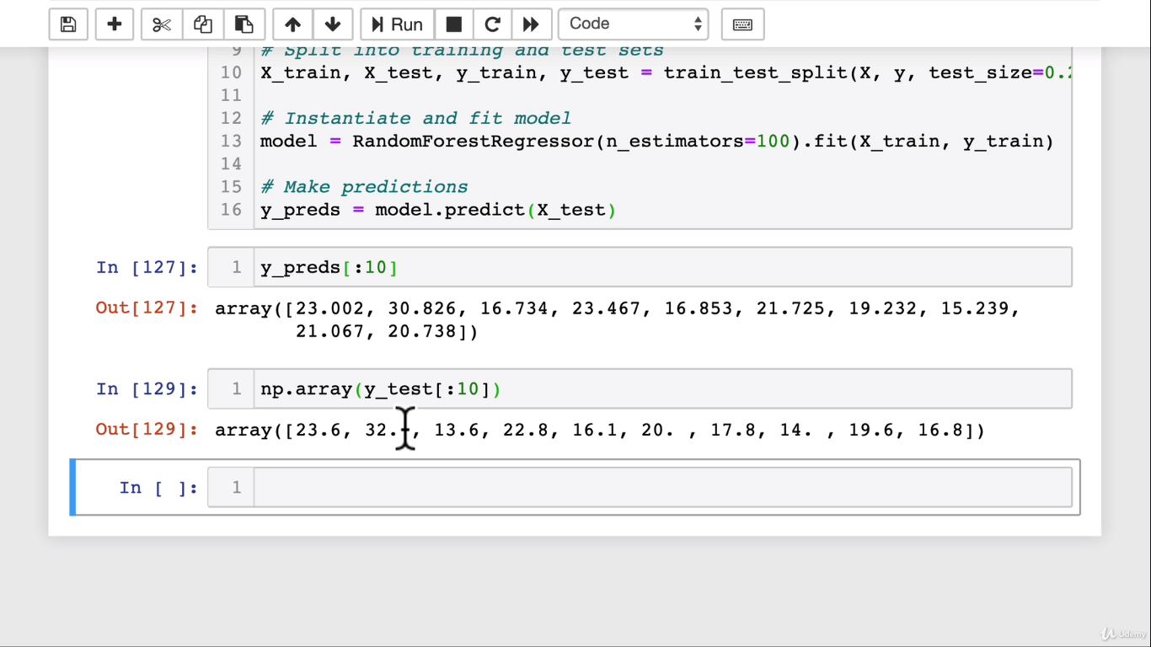

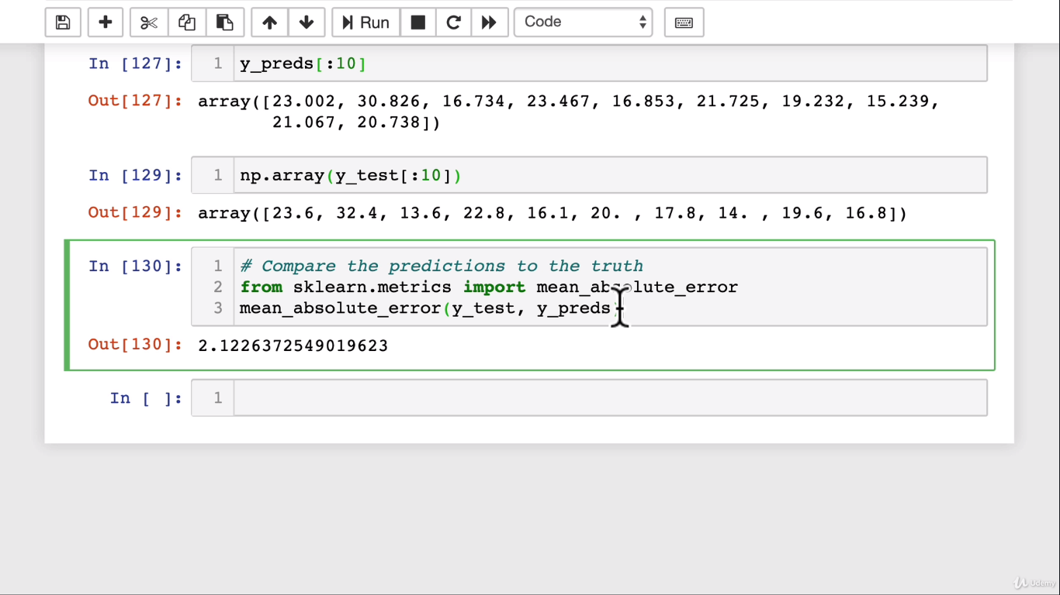

Above the predicted value differs from original Y value by 2.12 on an average

**Now, Let’s evaluate a Model:**

Three ways to evalauate scikit-learn models/estimators

1. **Estimator ‘score’ method**
2. **The ‘scoring’ parameter**
3. **Problem-specific metric functions**

**1.Estimator ‘score’ method**

from sklearn.ensemble import RandomForestClassifier

np.random.seed(42)

X = heart_disease.drop(“Target”, axis = 1)

Y = heart_disease[“target”]

X_train,X_test,Y_train,Y_test = train_test_split(X,Y,test_size = 0.2)

clf = RandomForestClassifier()

clf.fit(X_train,Y_train)

clf.score(X_train,Y_train)

clf.score(X_test,Y_test)

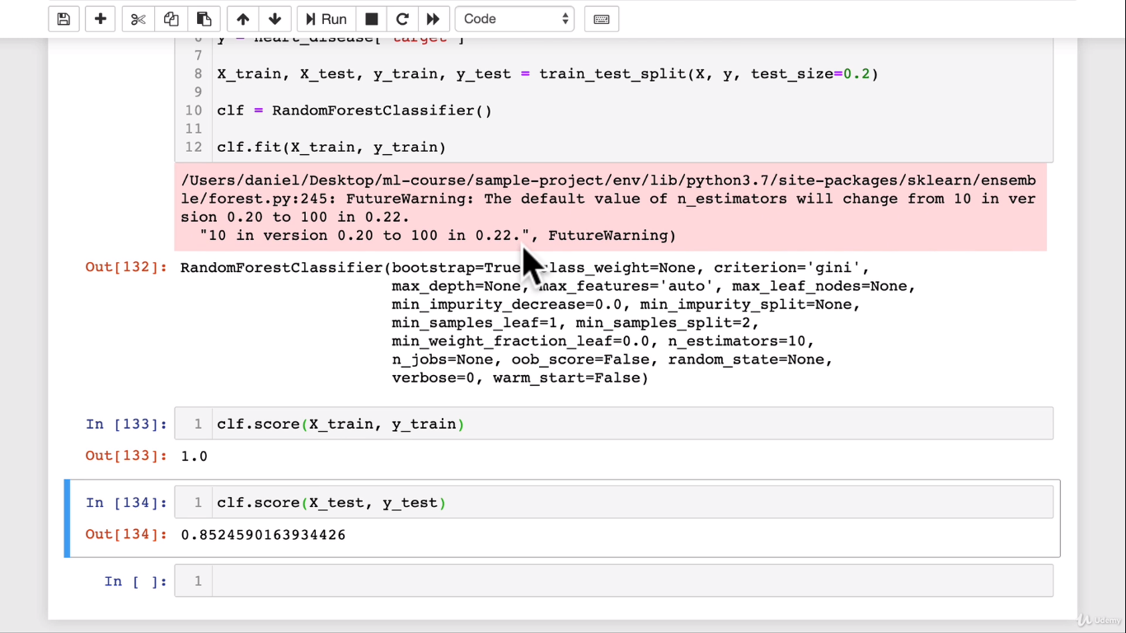

**Let’s do the same for regression:**

from sklearn.ensemble import RandomForestRegressor

np.random.seed(42)

#create the data

X = boston_df.drop(“target”, axis = 1)

Y = boston_df[“target”]

**#split the training and testing set**

X_test,X_train,Y_test,Y_train = train_test_split(X,Y,test_size=0.2)

**#Instantiate and fit the model**

model = RandomForestRegressor(n_estimators = 100).fit(X-train,Y_train)

#Make Predictions

model.score(X_test,Y_test)

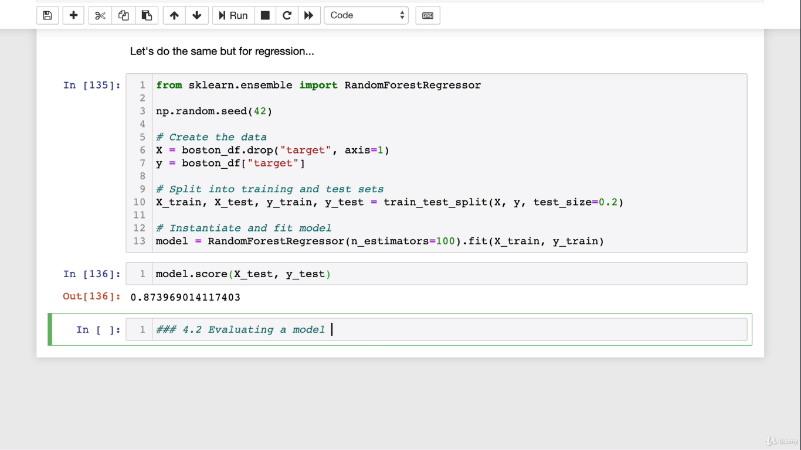

**NOTE:**

Classification model goes by **mean value** and regressor goes by **coefficient determination**

**2. Estimator ‘scoring parameter’ method**

from sklearn.model_selection import cross_val_score

from sklearn.ensemble import RandomForestClassifier

np.random.seed(42)

X = heart_disease.drop(“Target”, axis = 1)

Y = heart_disease[“target”]

X_train,X_test,Y_train,Y_test = train_test_split(X,Y,test_size = 0.2)

clf = RandomForestClassifier(n_estimators = 100)

clf.fit(X_train,Y_train)

clf.score(X_train,Y_train)

cross_val_score(clf,X,Y,cv=5)

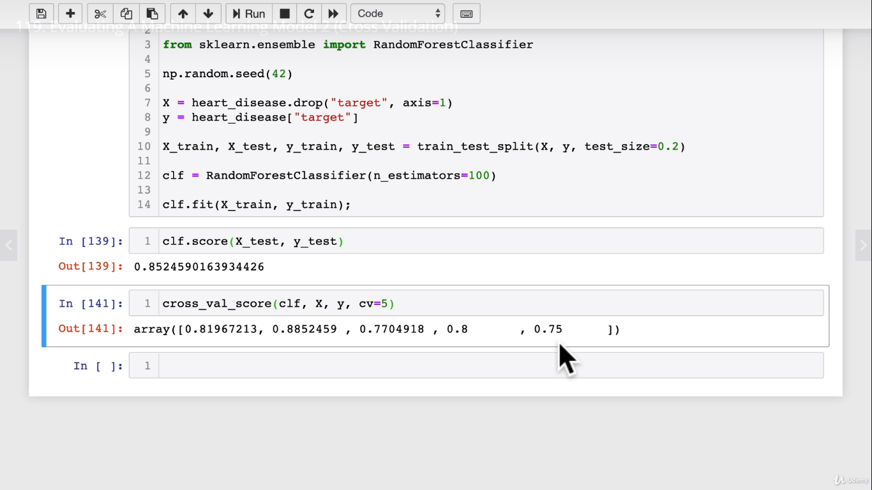

Cross_val_score returns **an array** whereas score returns **a number**

**What is cross_Validation**

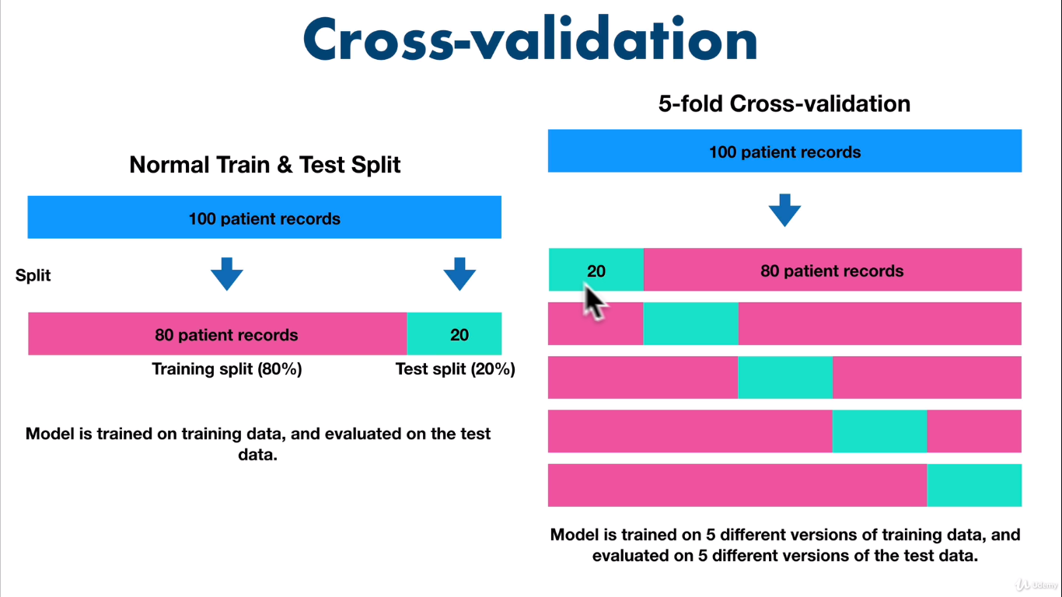

**Scoring parameter is set to None by default:**

**The default parameter will be set to None or of it is None then it will use the default scoring parameter.**

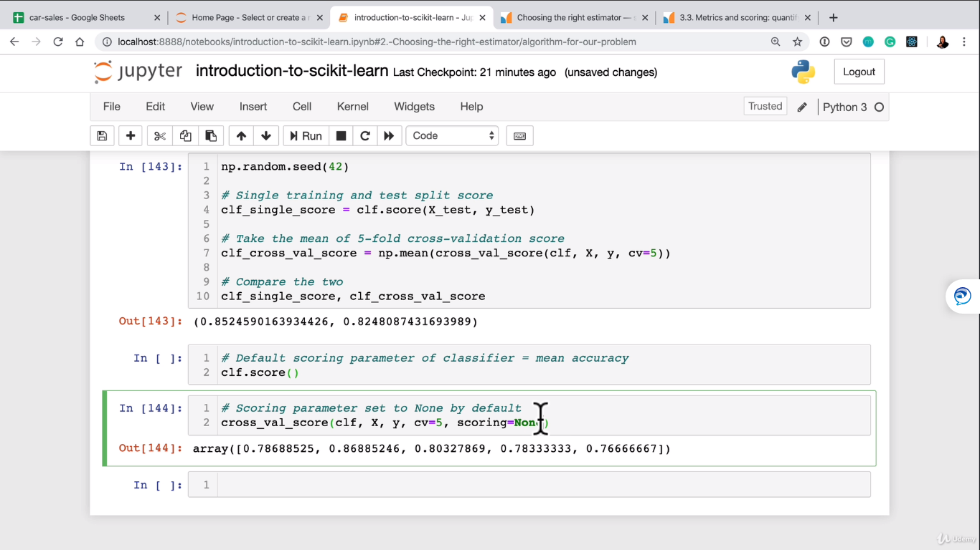

**Classification and Model evaluation metrics:**

1. Accuracy
2. Area under ROC curve
3. Confusion Matrix
4. Classification report
5. Accuracy

Below code will tell us that 8/10 times our model will do the predictions right.

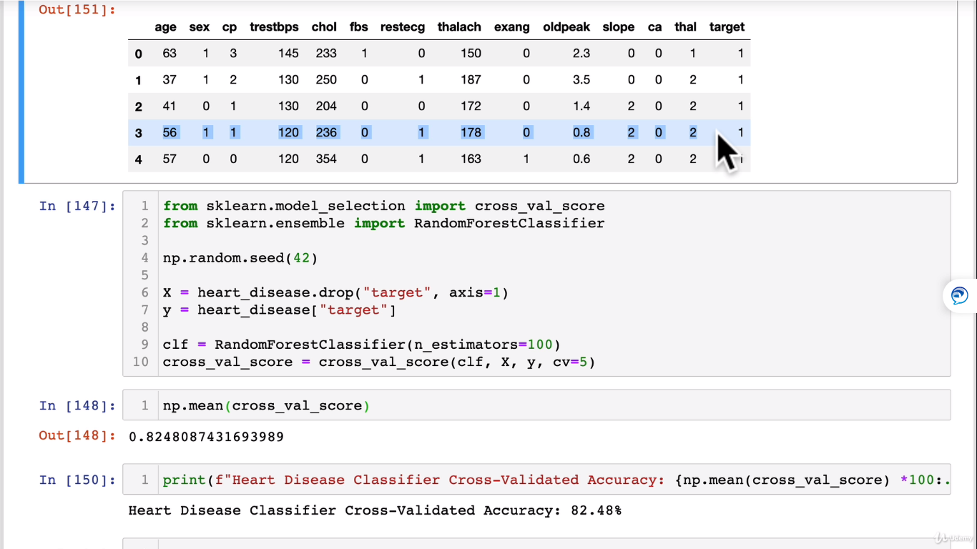

1. Area under ROC curve(AUC / ROC Area under the curve or receiver operating characteristic curve).

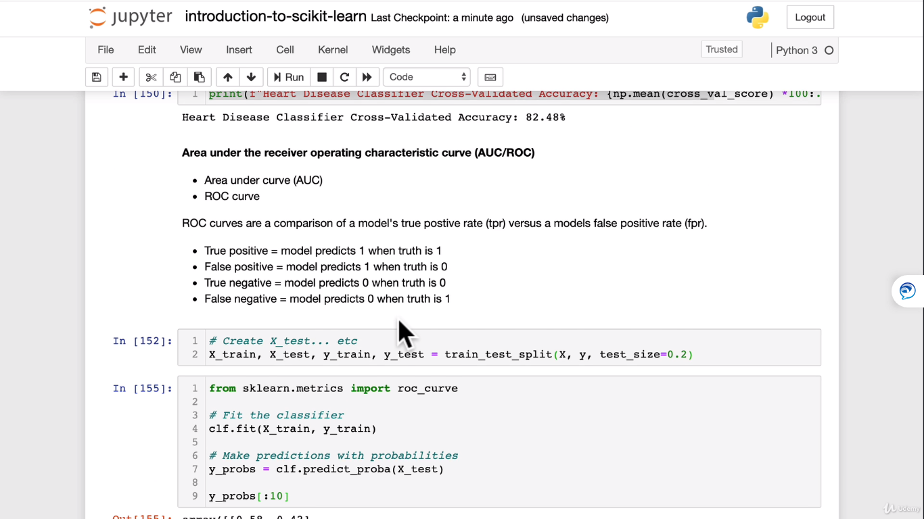

Fpr(false positive rate) and tpr(true positive rate):

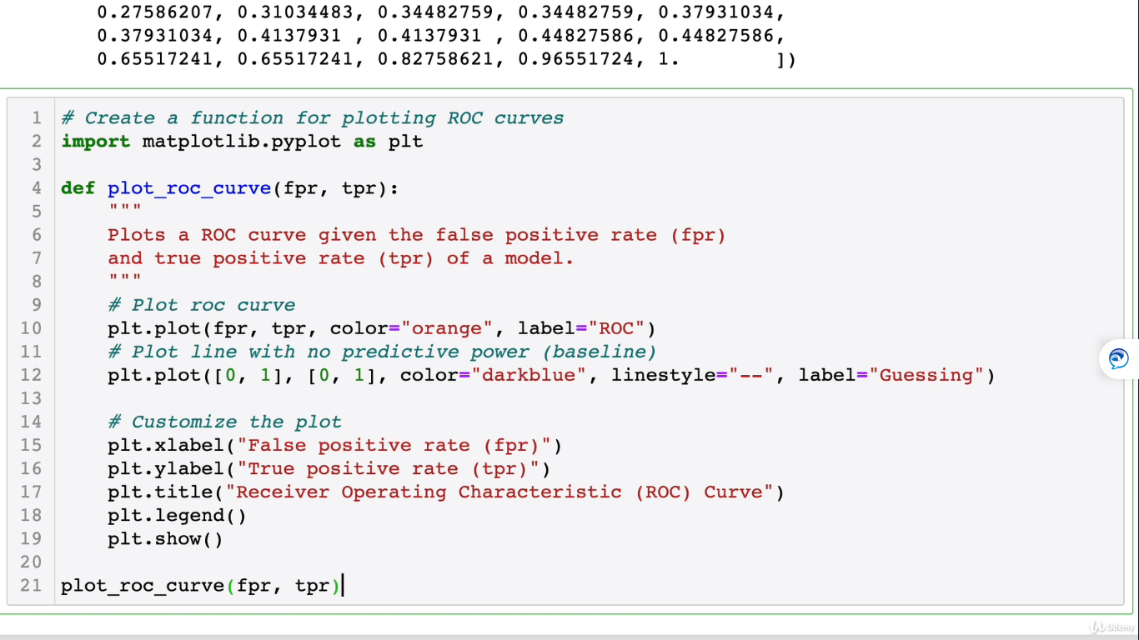

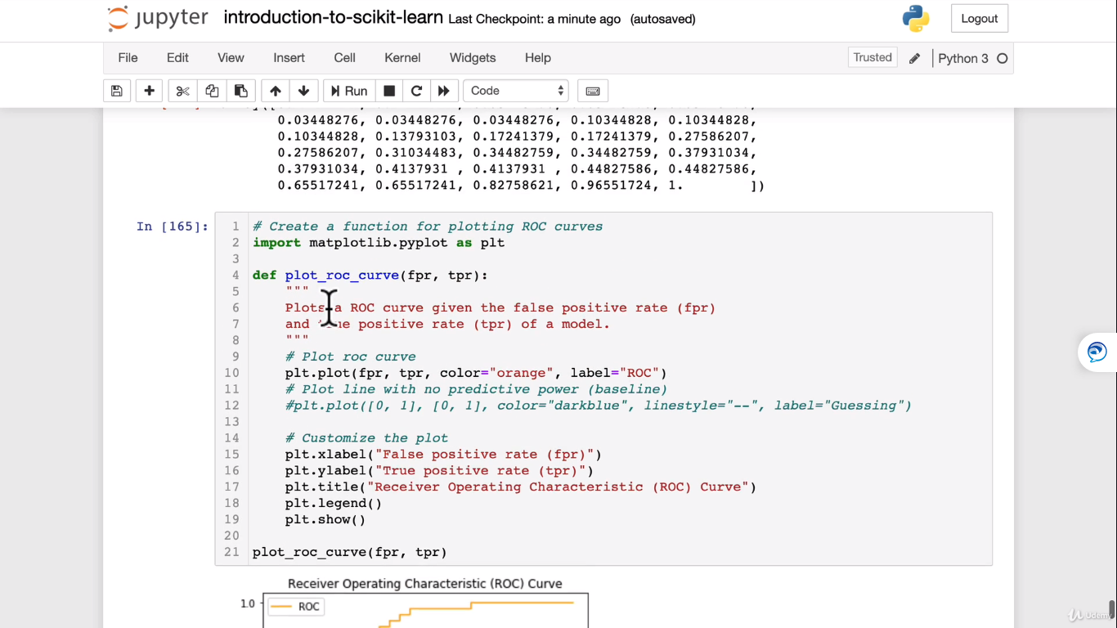

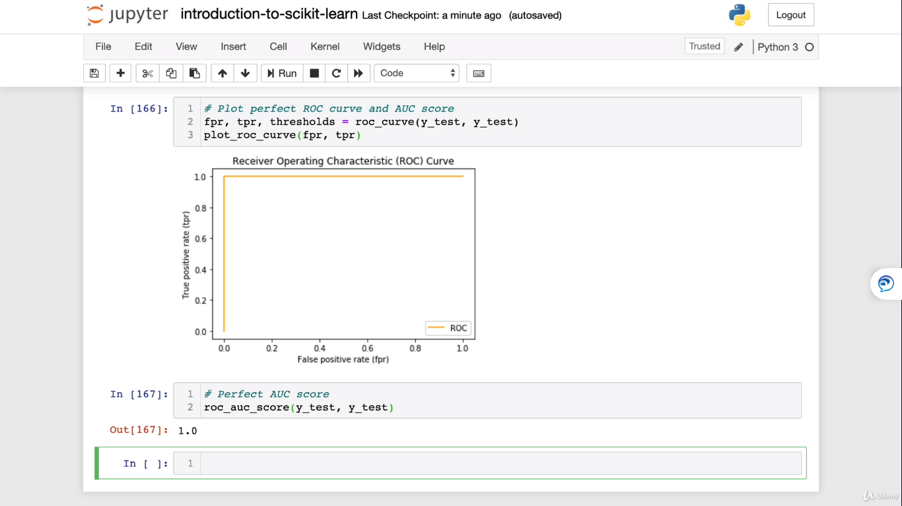

1. **Confusion Matrix:**

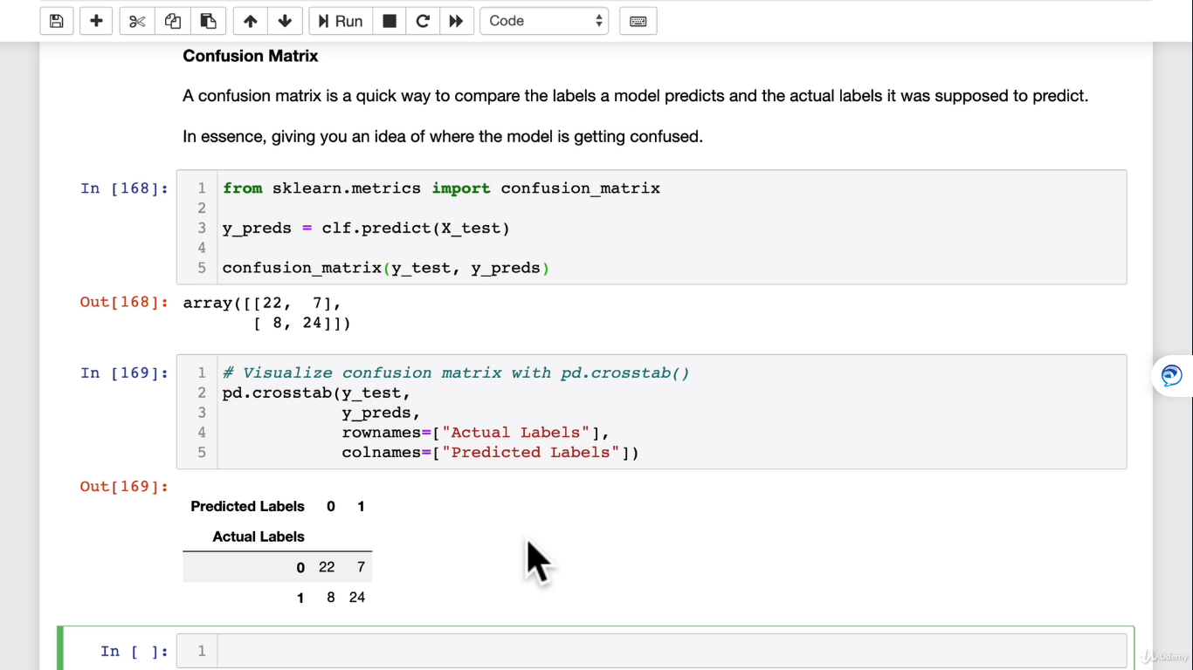

**Confusion matrix anatomy:**

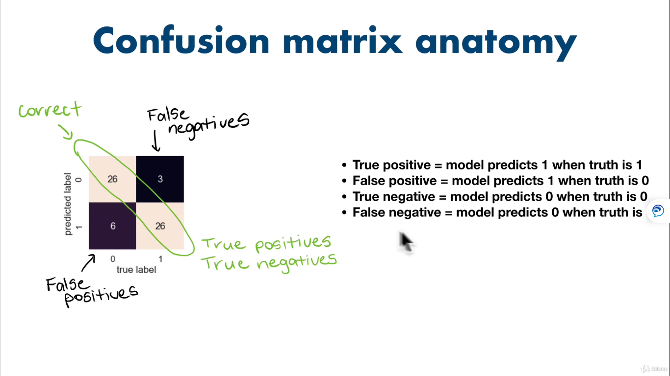

**Seaborn’s heatmap:**

It’s a visualization library built on top of matplotlib

You can install seaborn by below:

Conda install seaborn in the console

Or you can install seaborn with in jupyter notebook

import sys

!conda install –yes –prefix {sys.prefix} seaborn

This should install seaborn

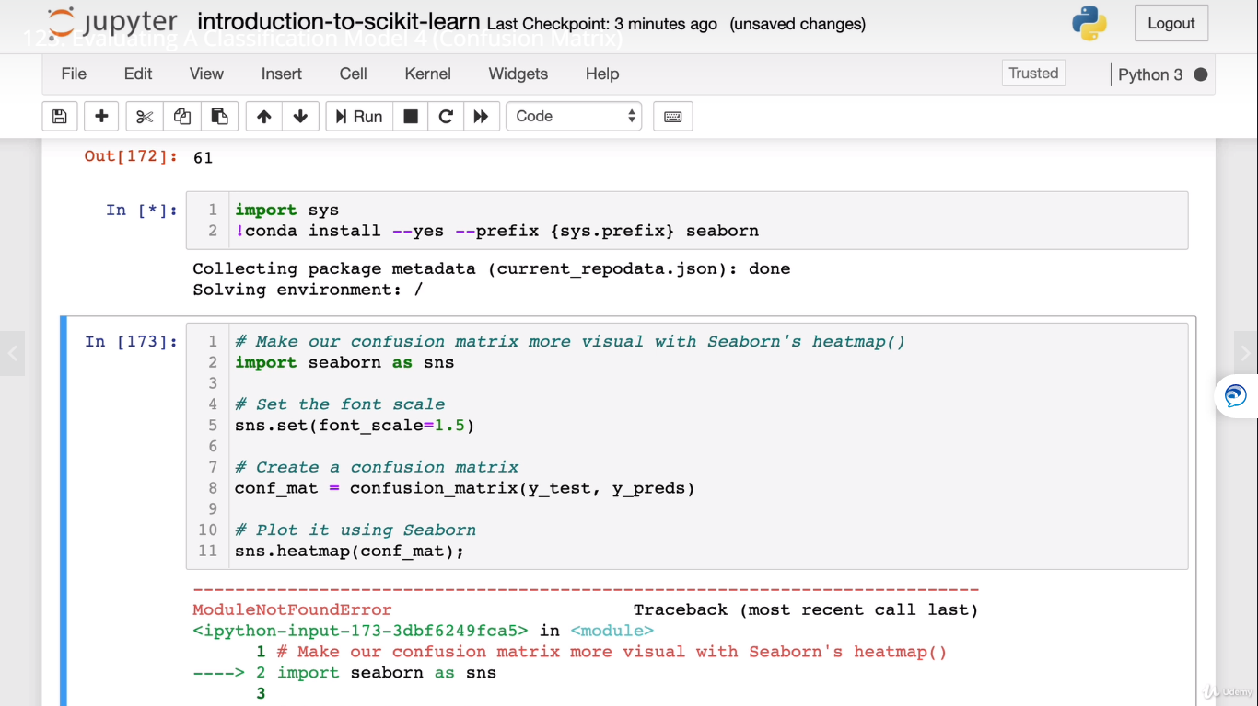

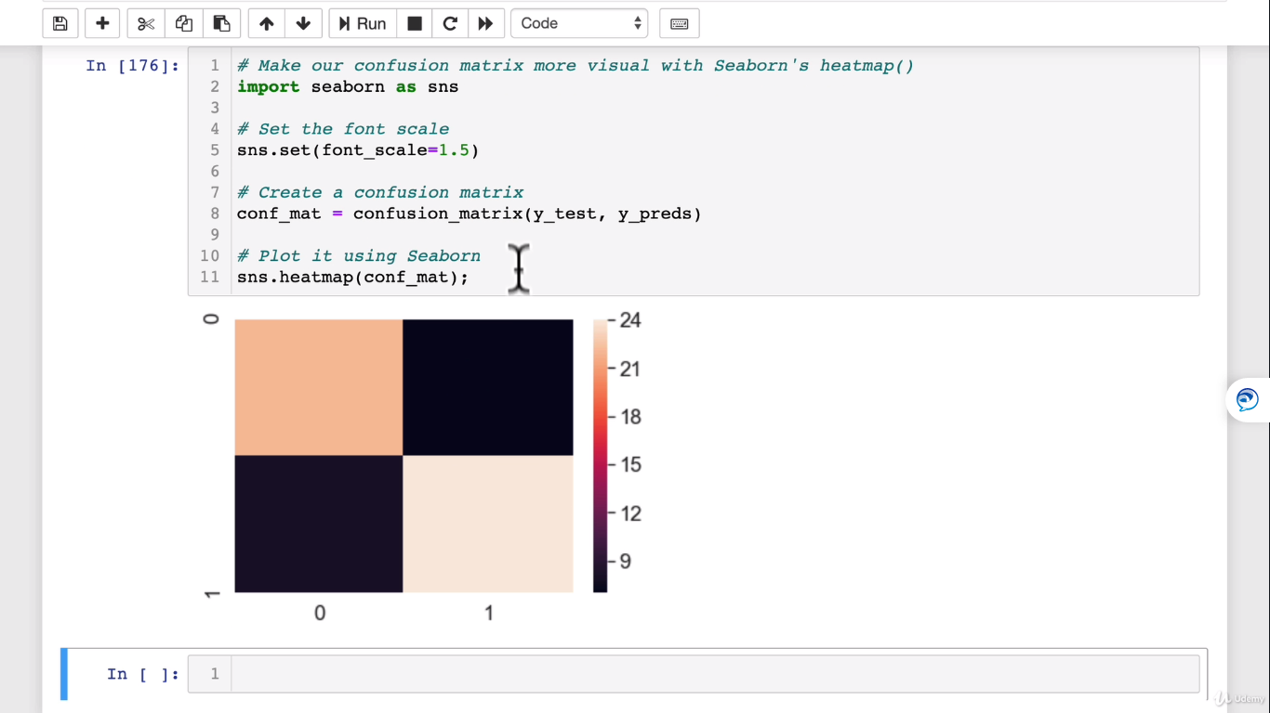

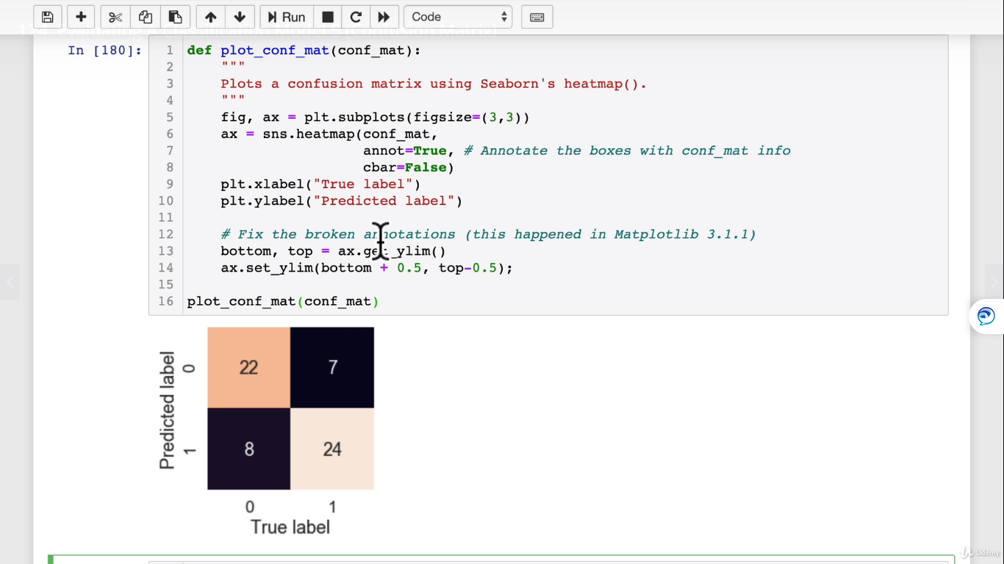

1. **Classification Report:**

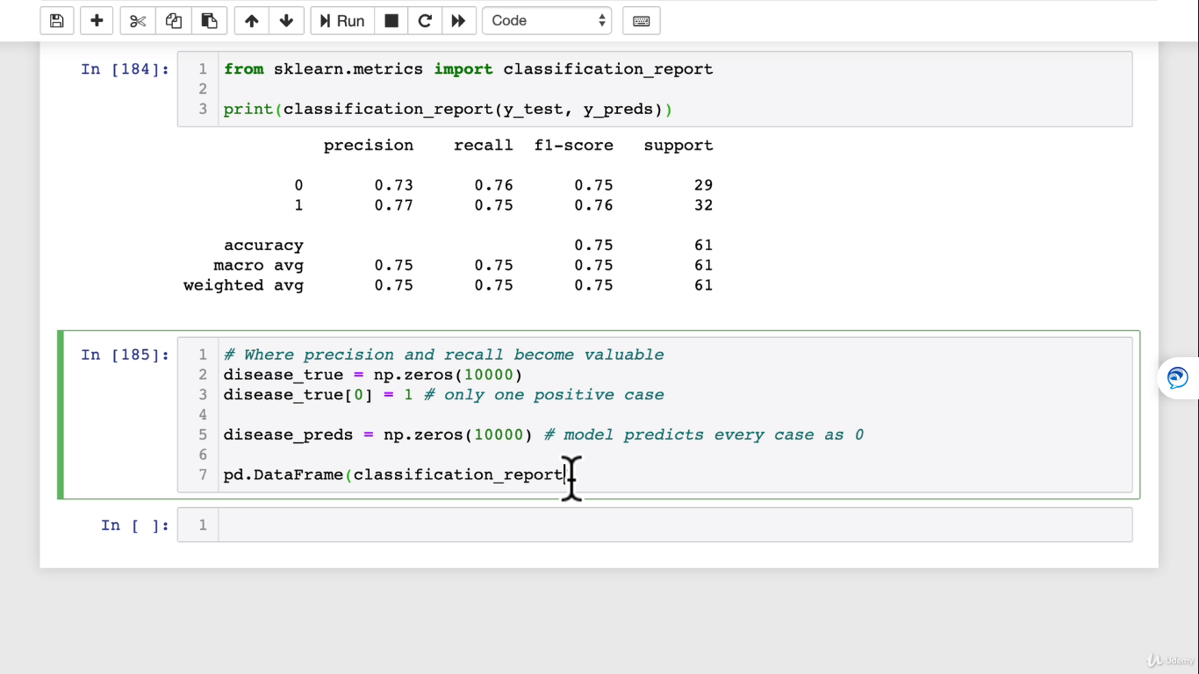

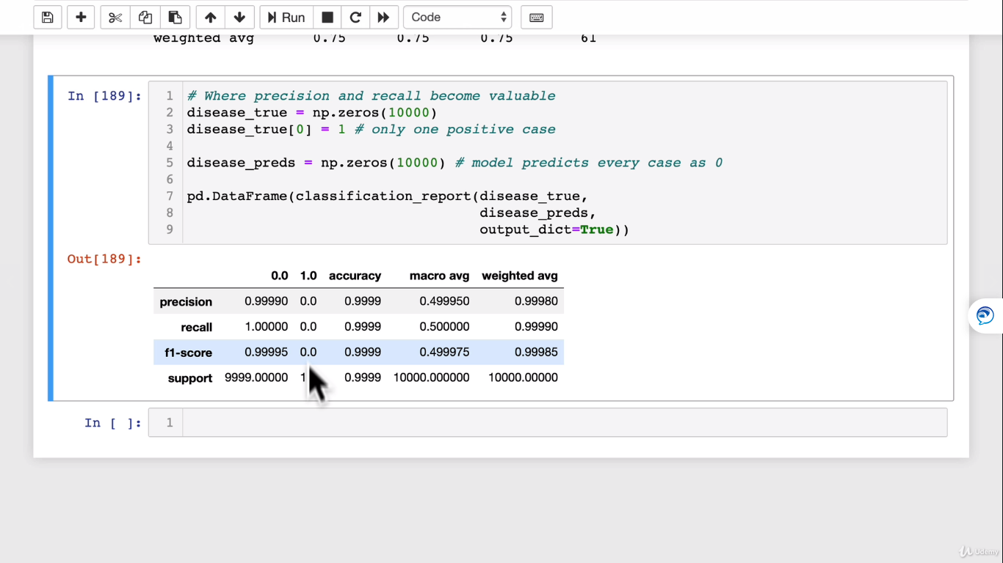

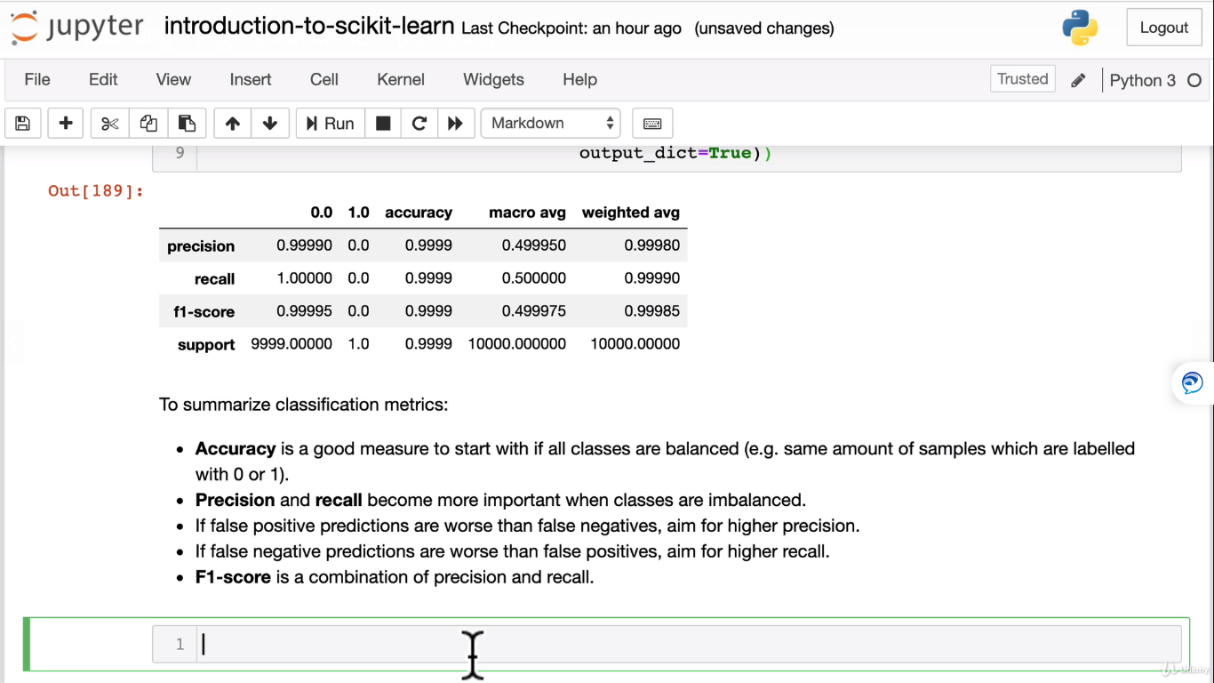

**Regression model evaluation metrics:**

**R2 Score: or R^2 or R squared metrics:**

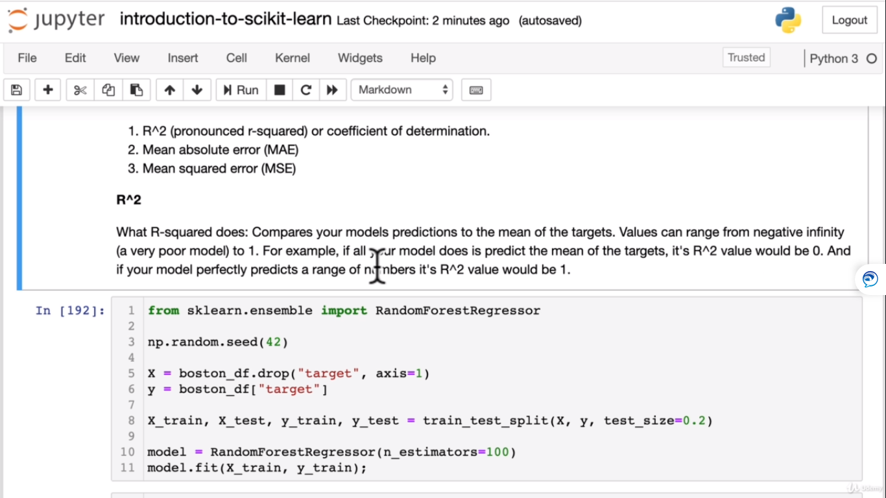

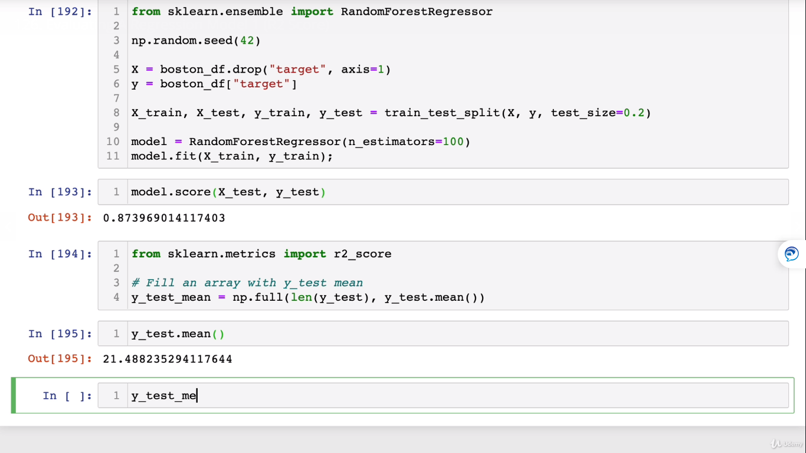

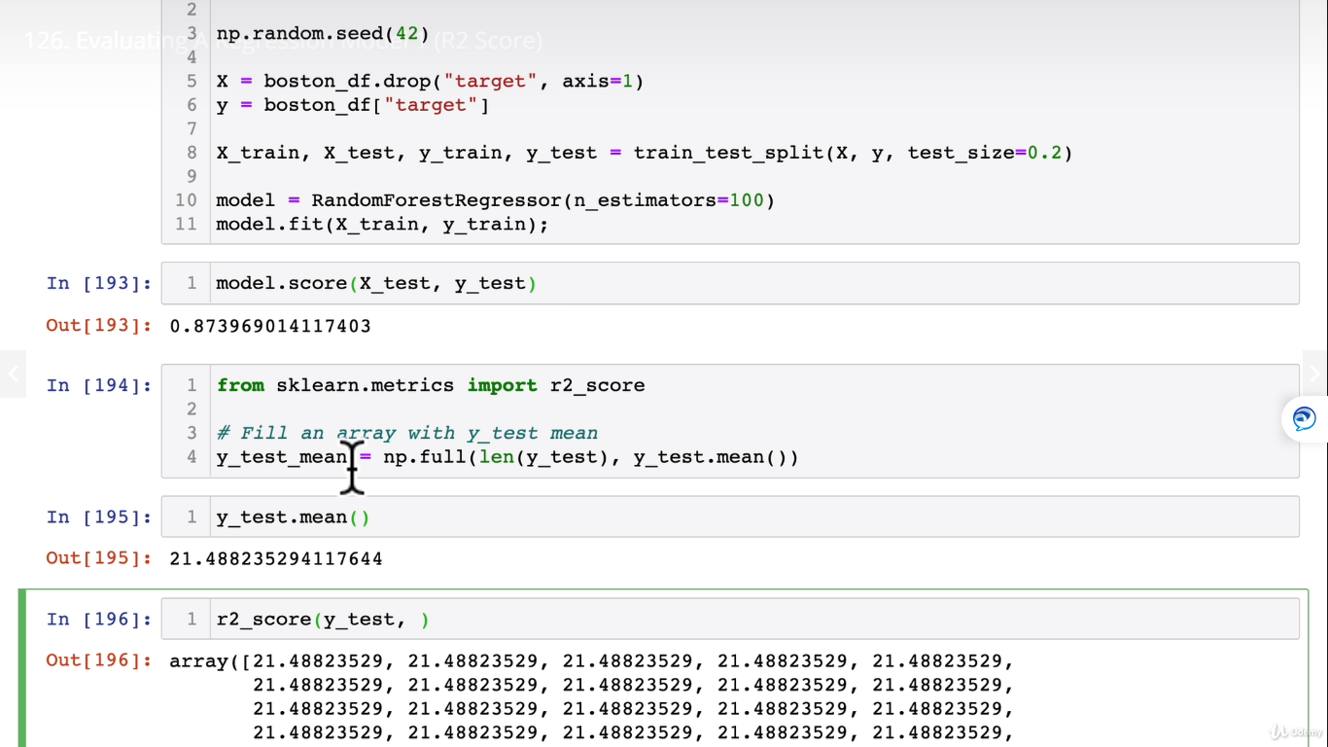

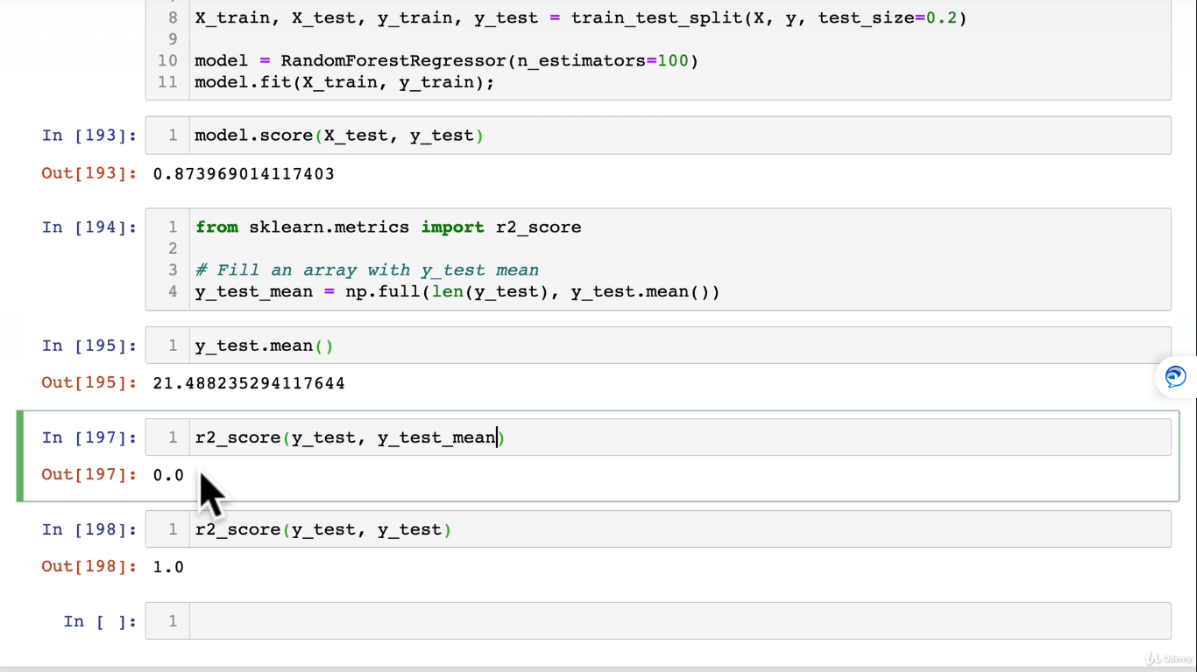

**Mean Absolute Error (MAE):**

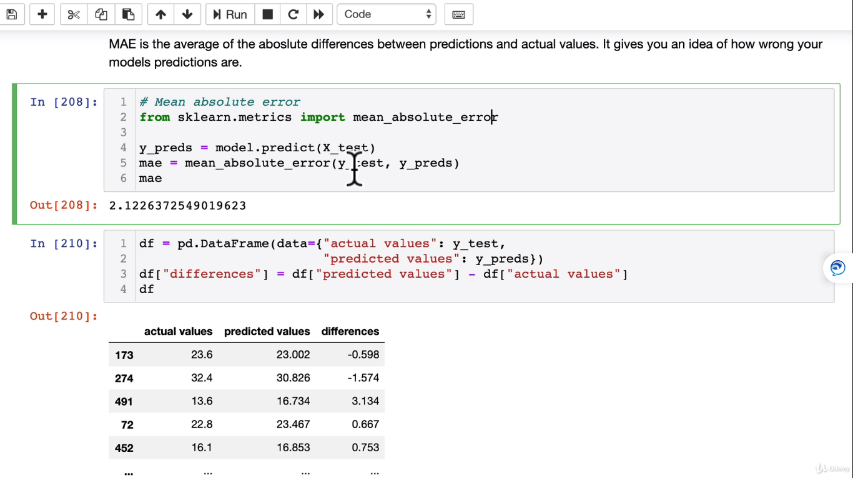

**Mean Squared Error(MSE):**

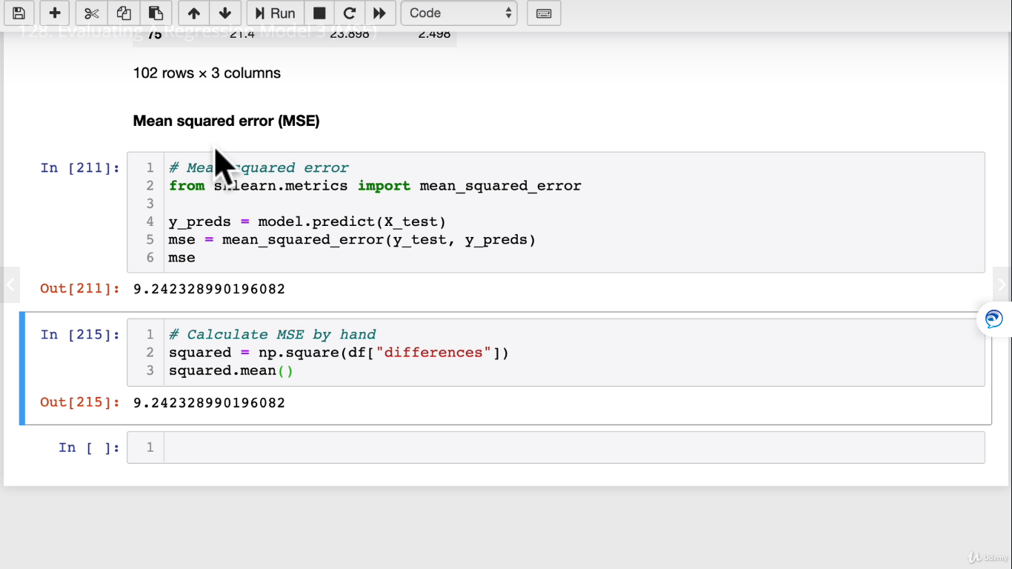

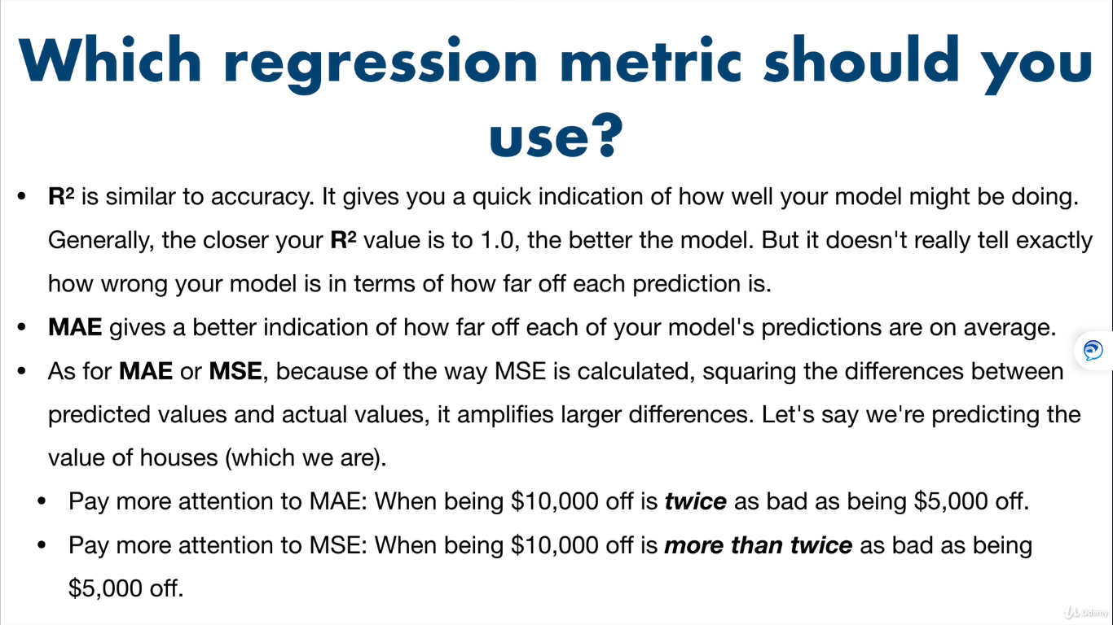

**For a good model metric:**

Minimize mean square error(MSE) and Mean Absolute error (MAE) and maximize R square (R^2)so that it is a good regression metric.

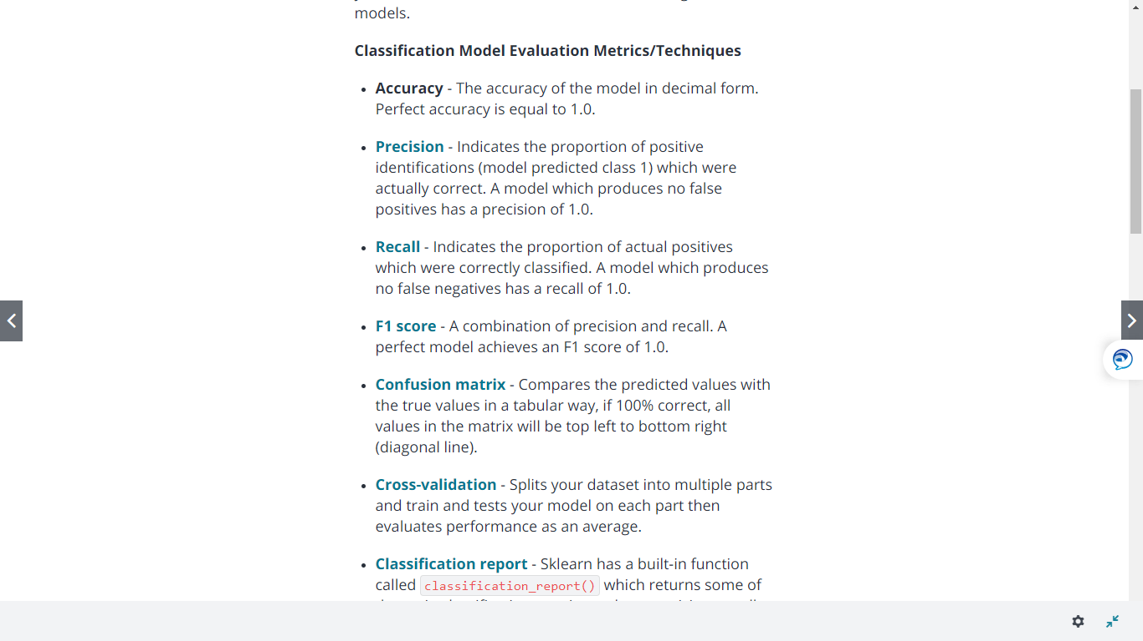

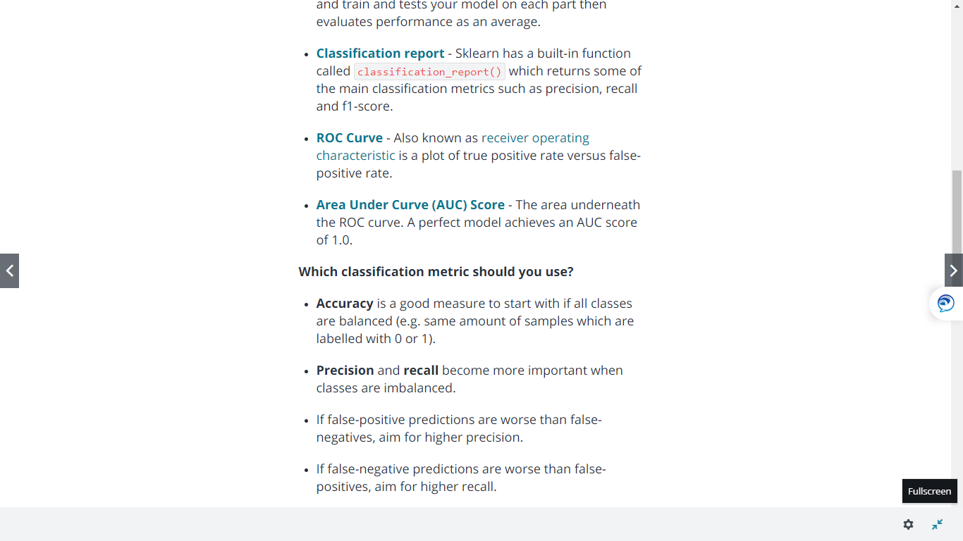

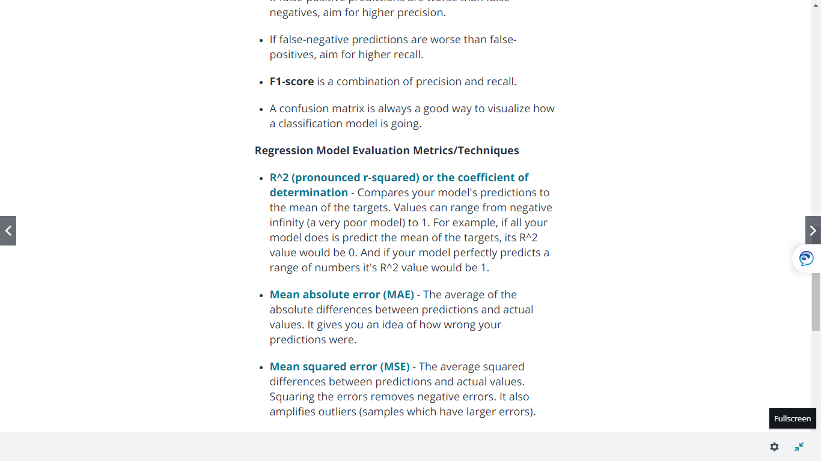

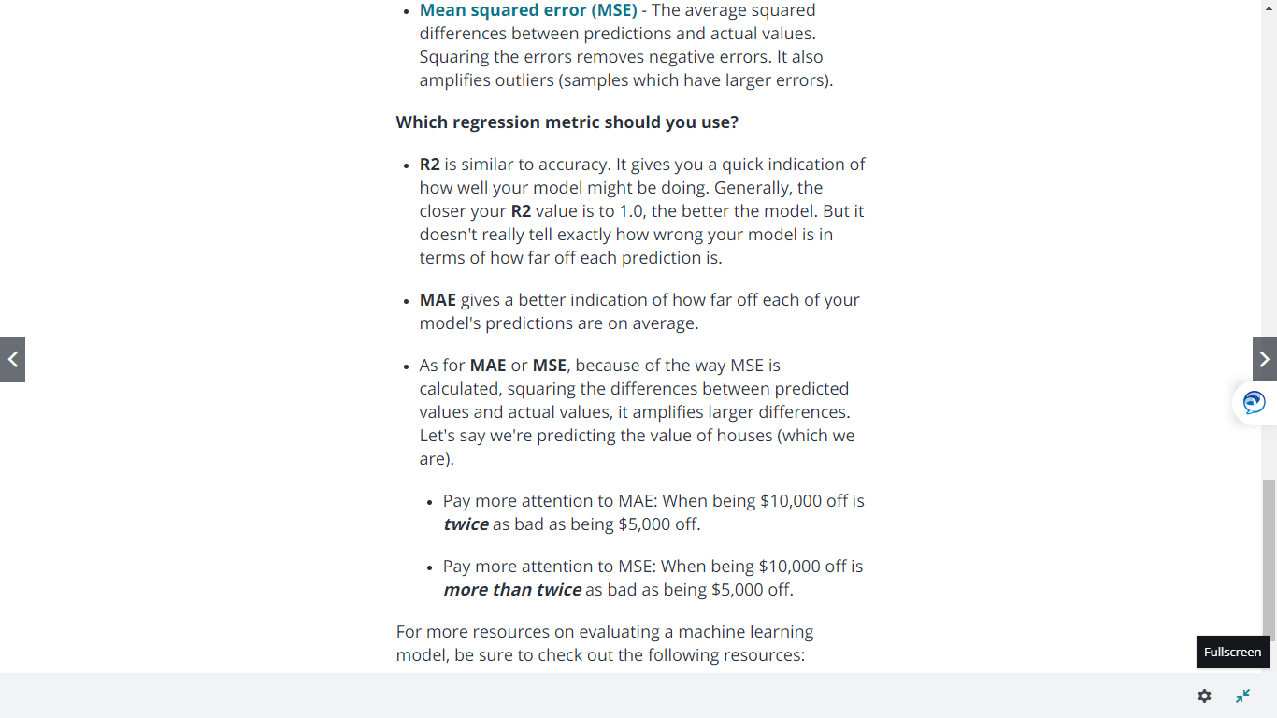

**Cross Validation and Scoring Parameter:**

**For Classificatiobn Model:**

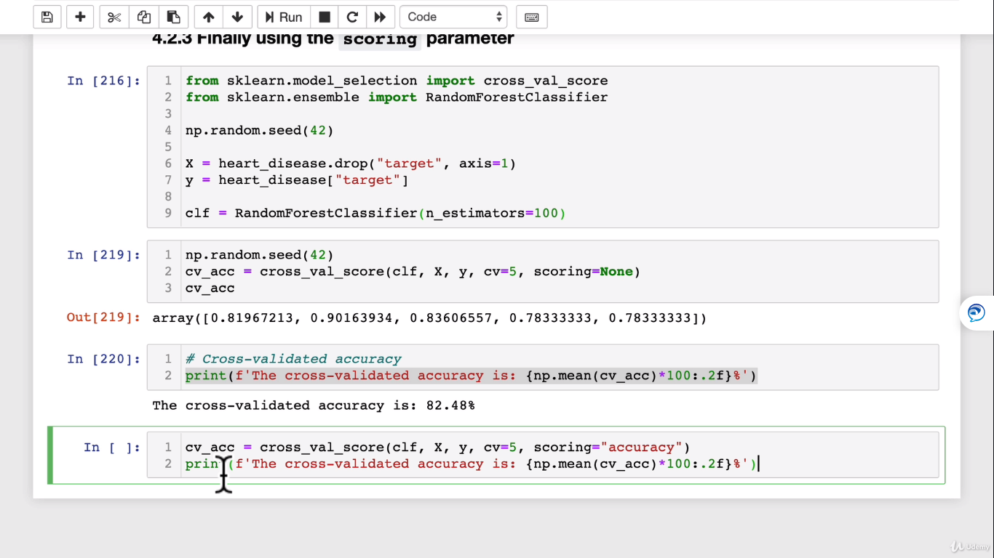

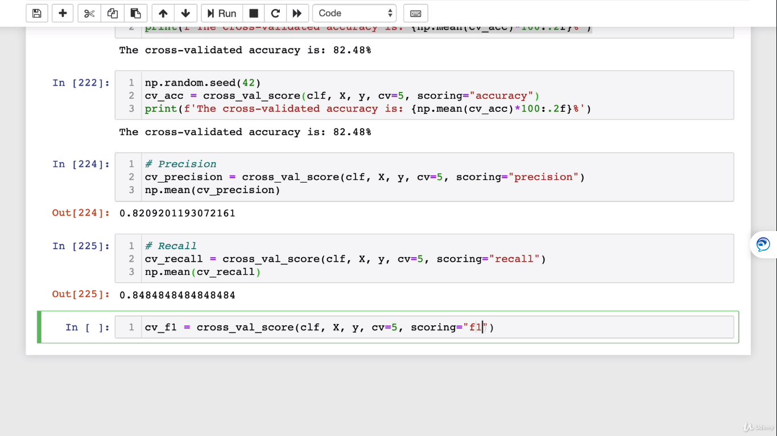

**For Regression Model:**

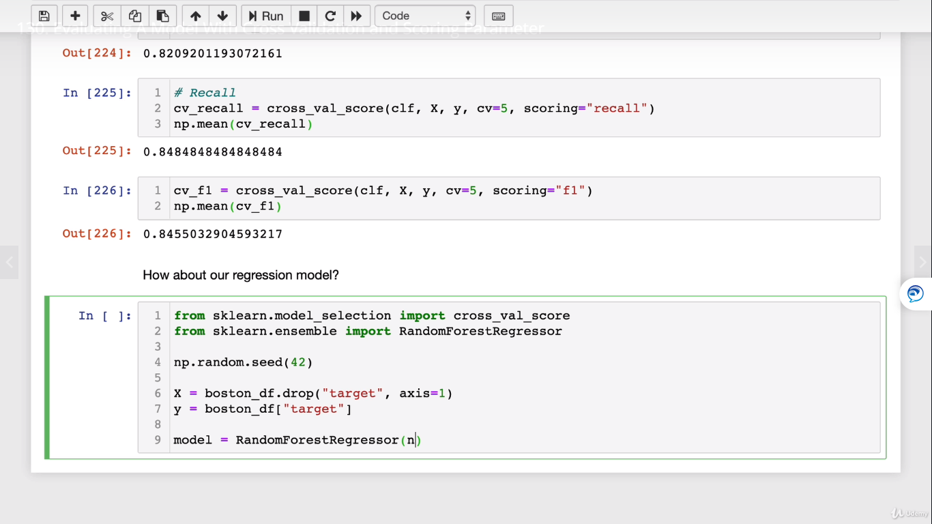

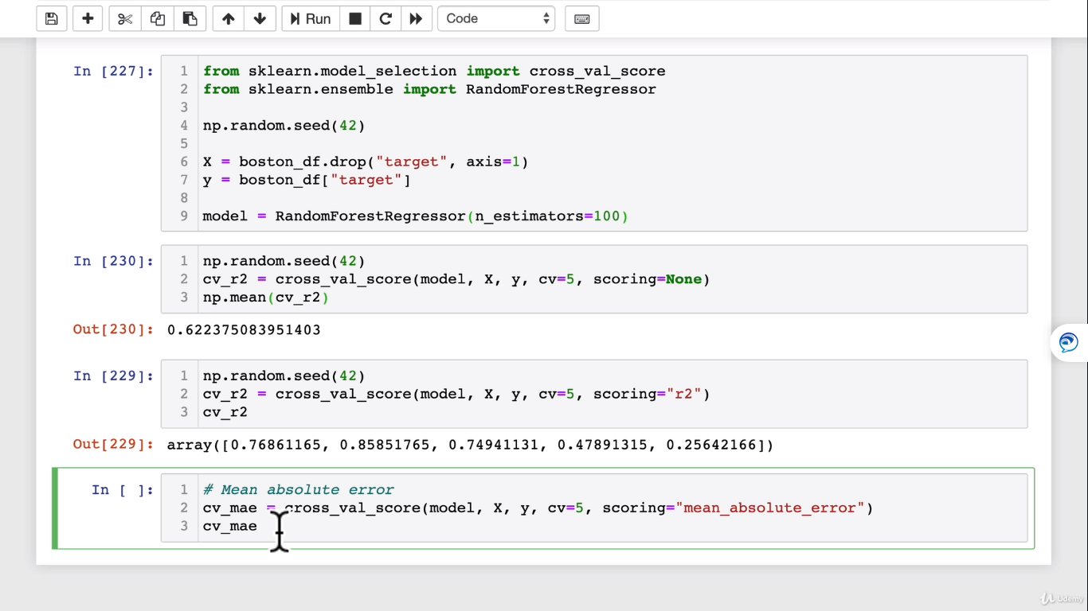

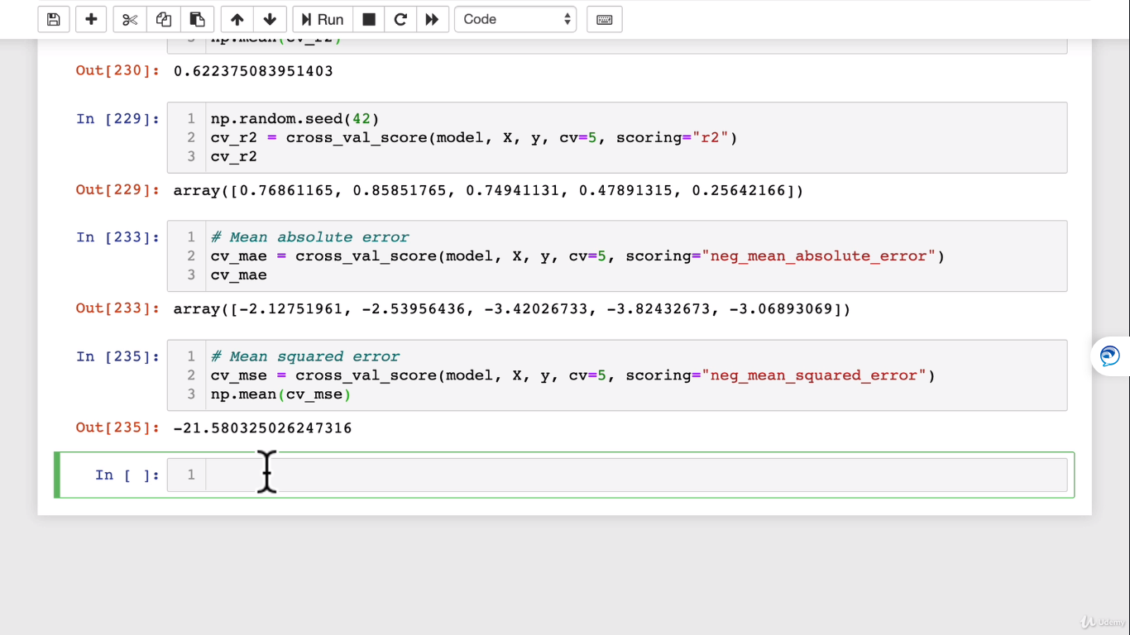

**Scikit-learn functions:**

**Classification Functions:**

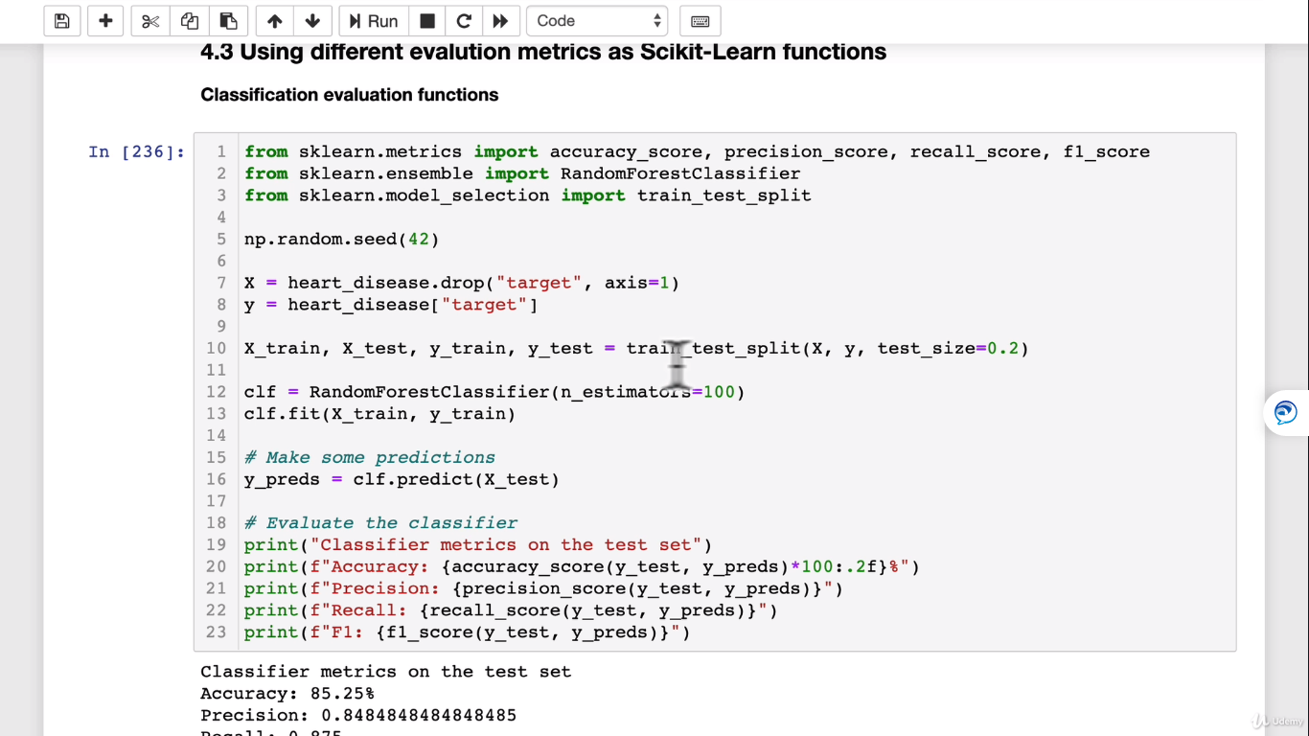

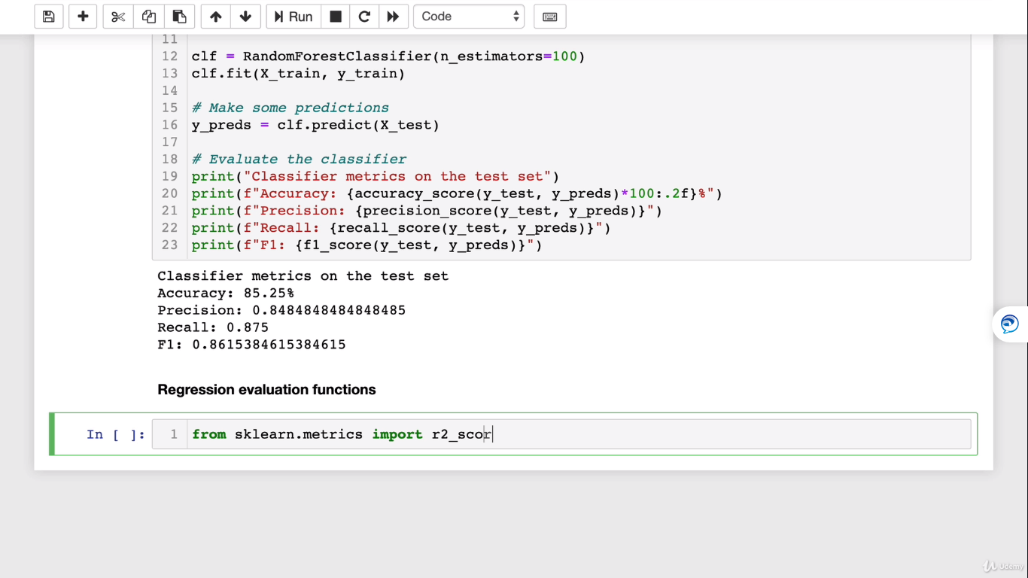

**Regression Functions:**

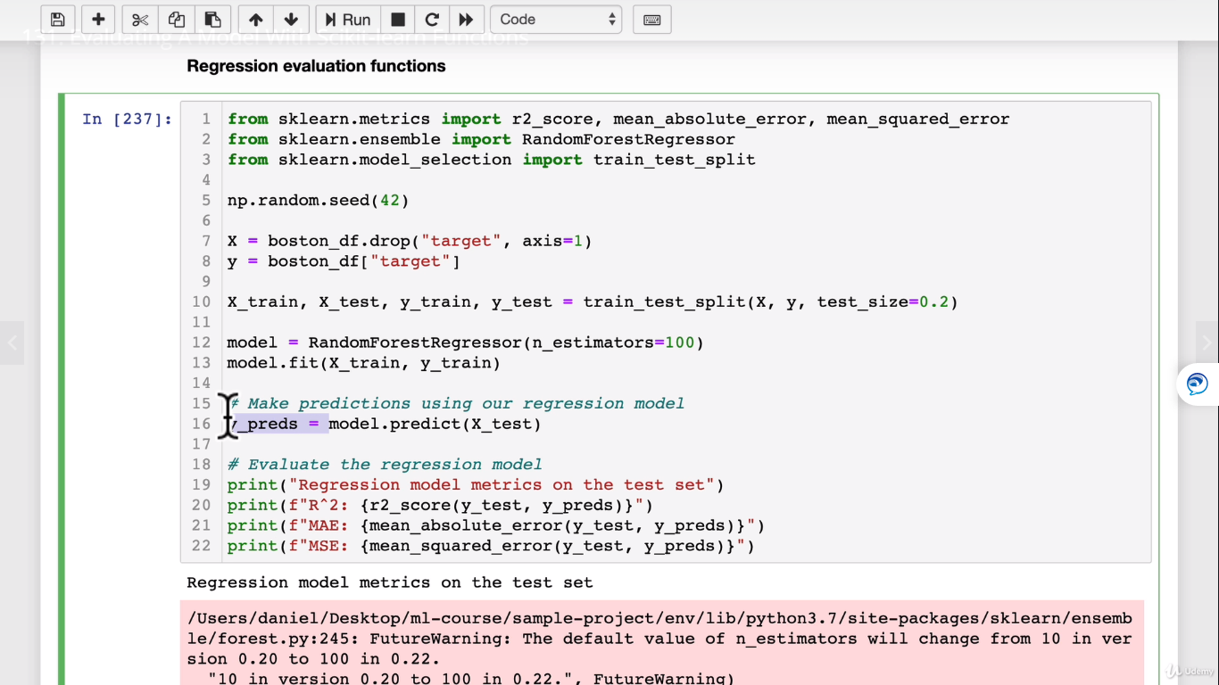

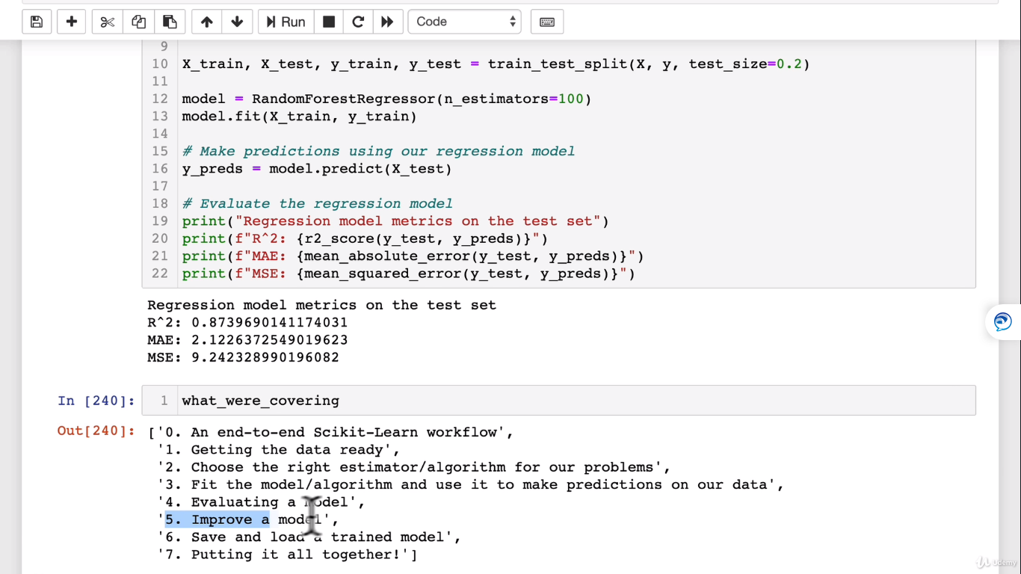

**Improving the model:**

**By adjusting hyperparameters:**

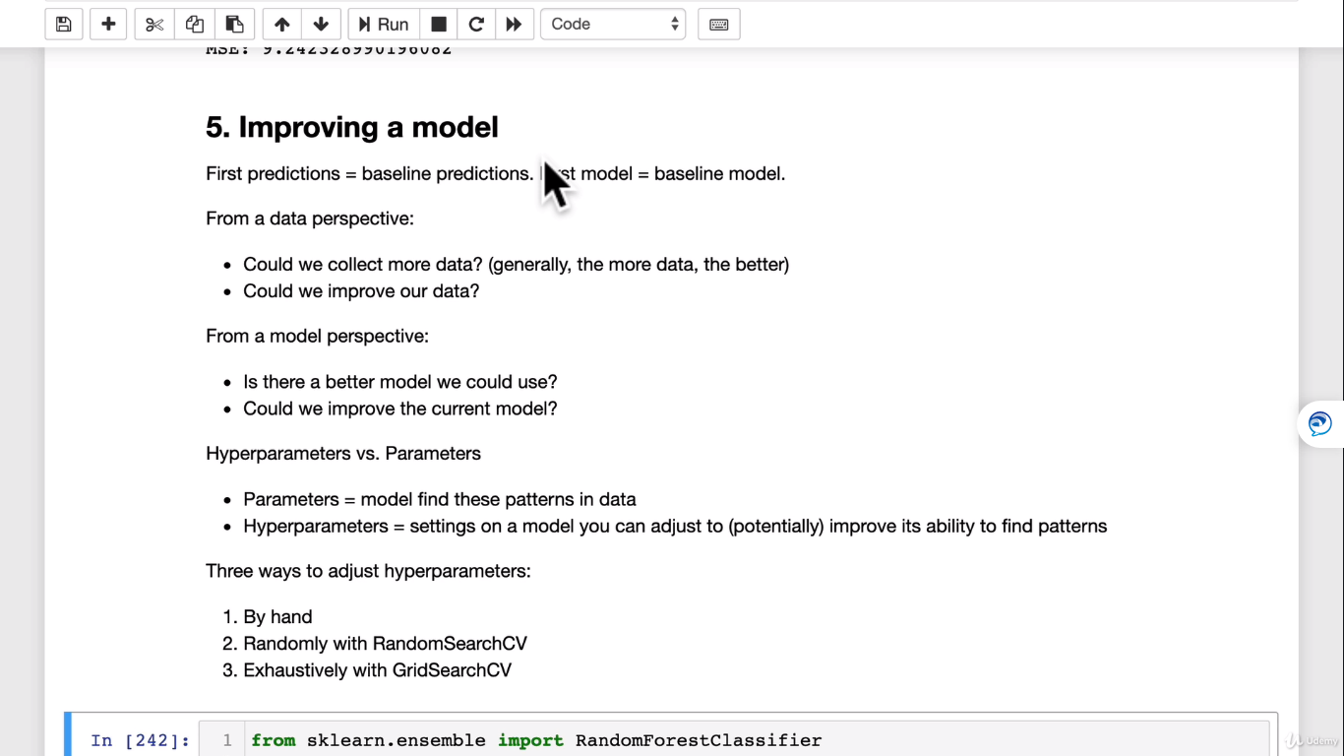

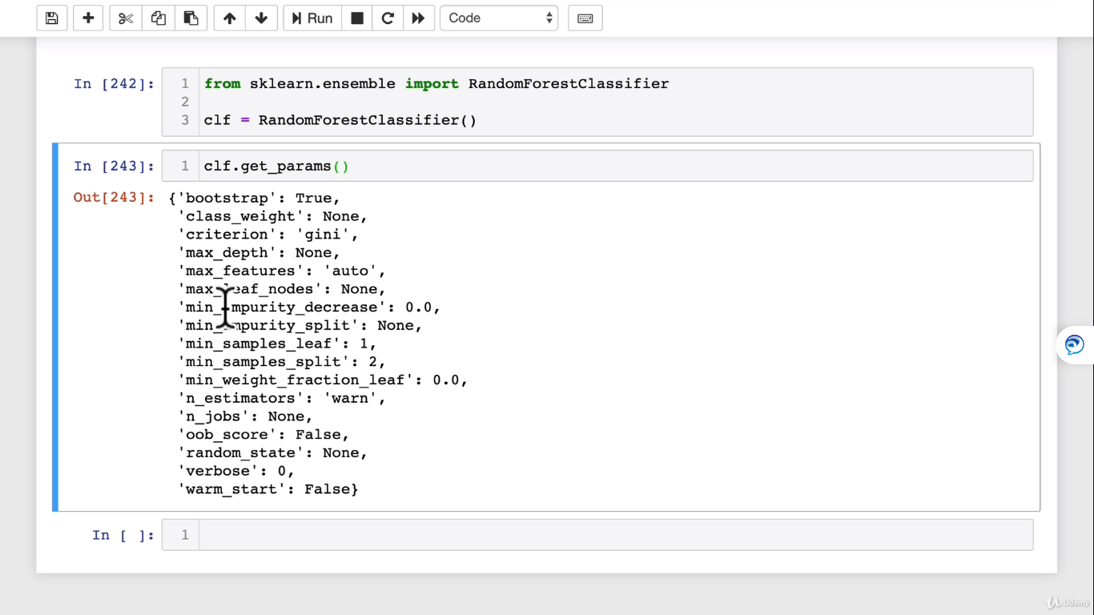

**Tuning hyper-parameters by hand:**

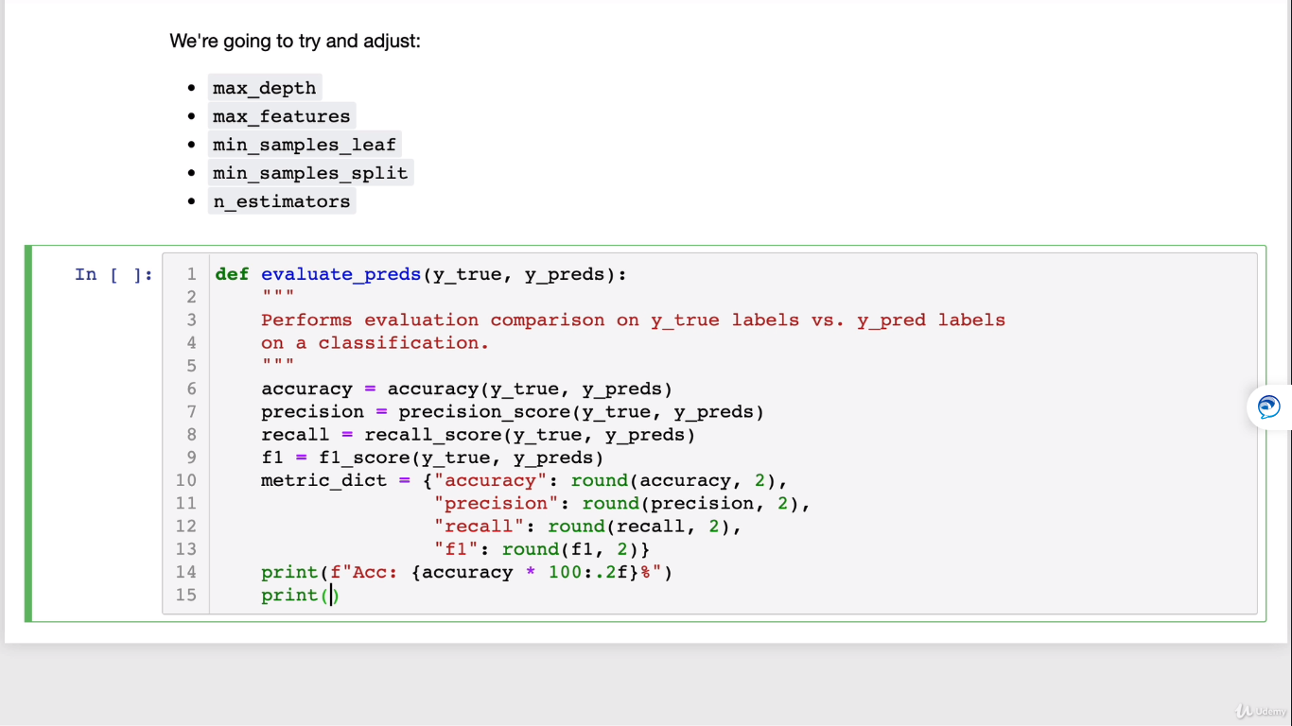

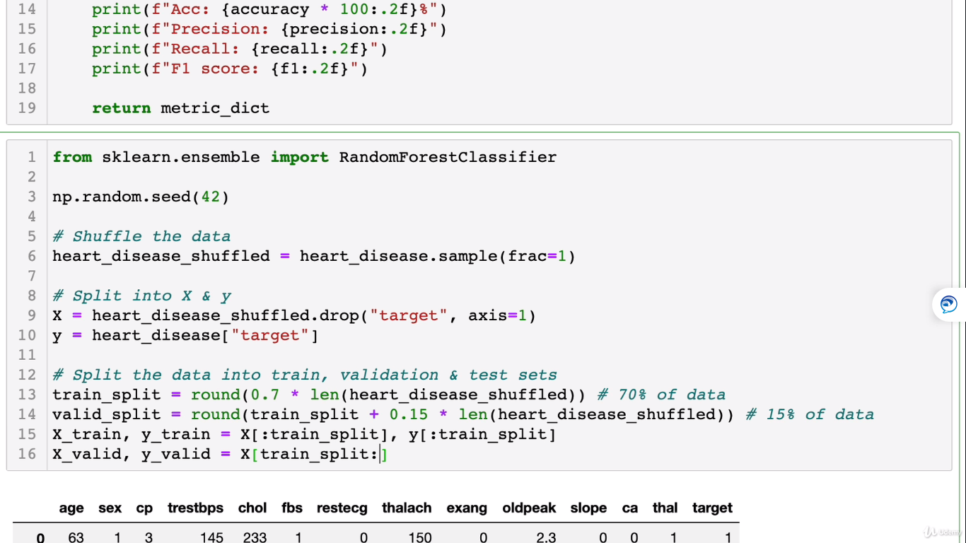

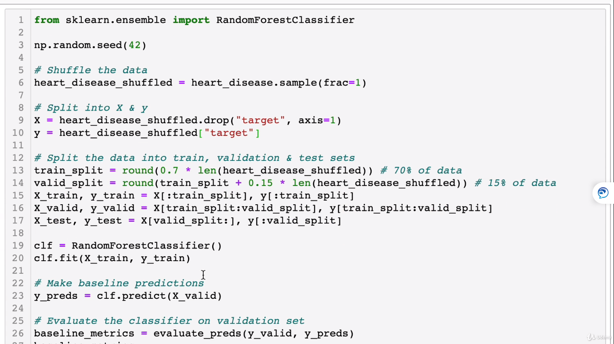

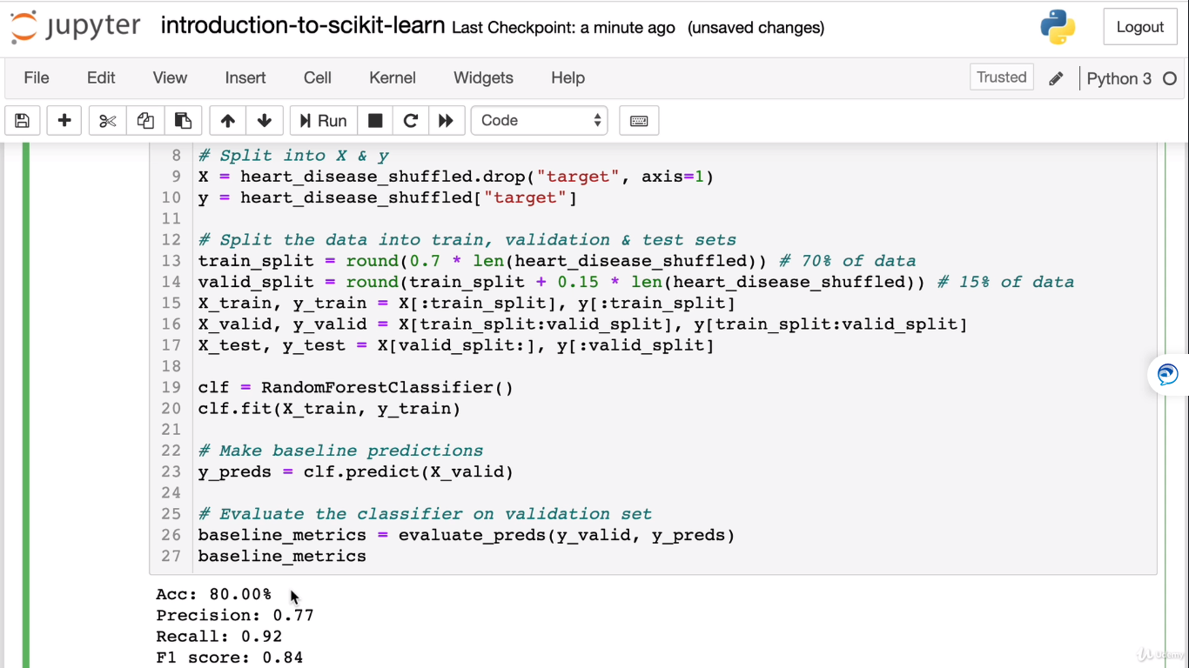

**Now let’s change the hayperparameter n_estimators:**

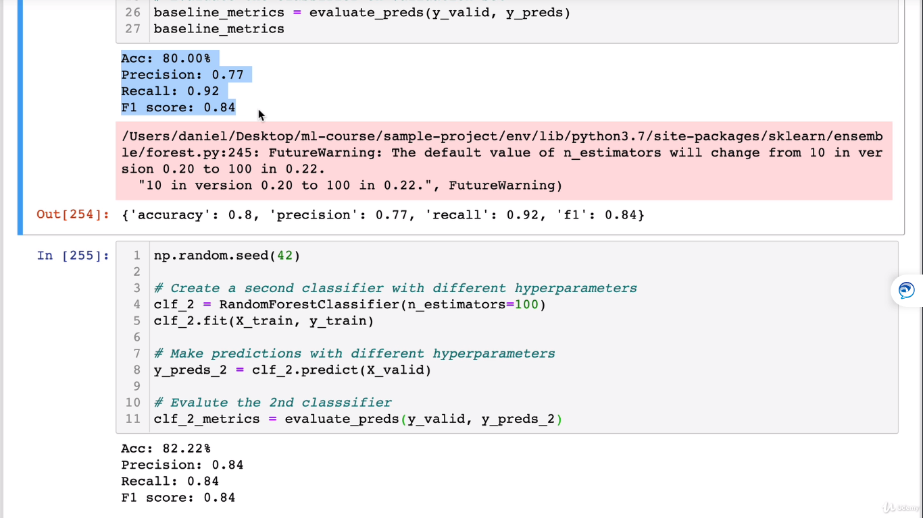

**Tuning with Randomized hyperparamter with RandomizedSearchCV**

This will give the best combination parameters to give us the best results by tuning hyperparamters all by itself.

from sklearn.model_selection import RandomizedSearchCV

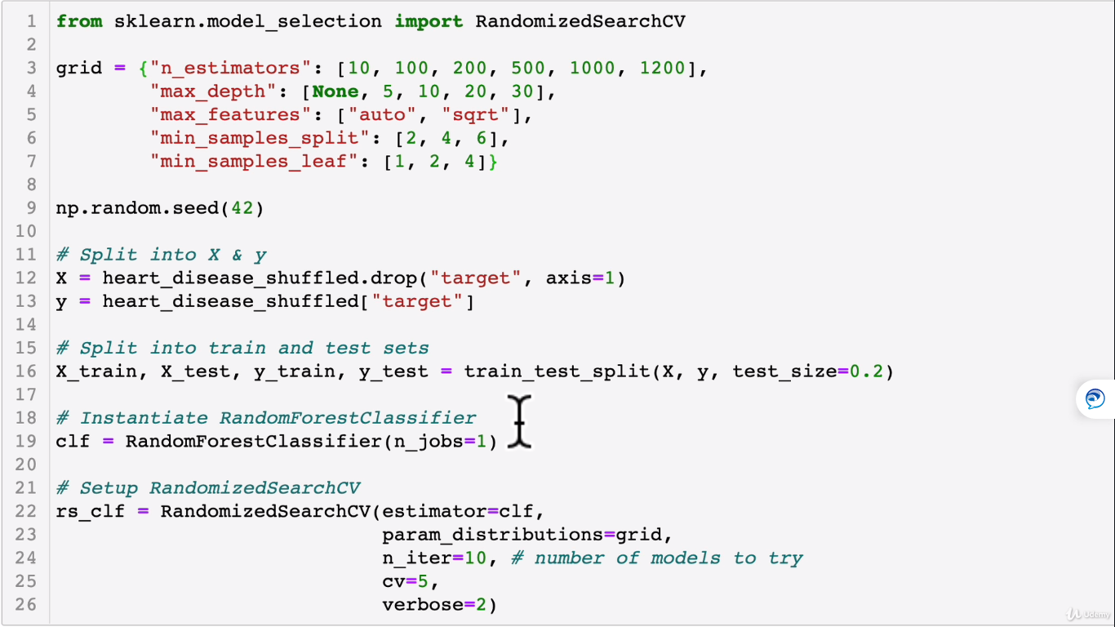

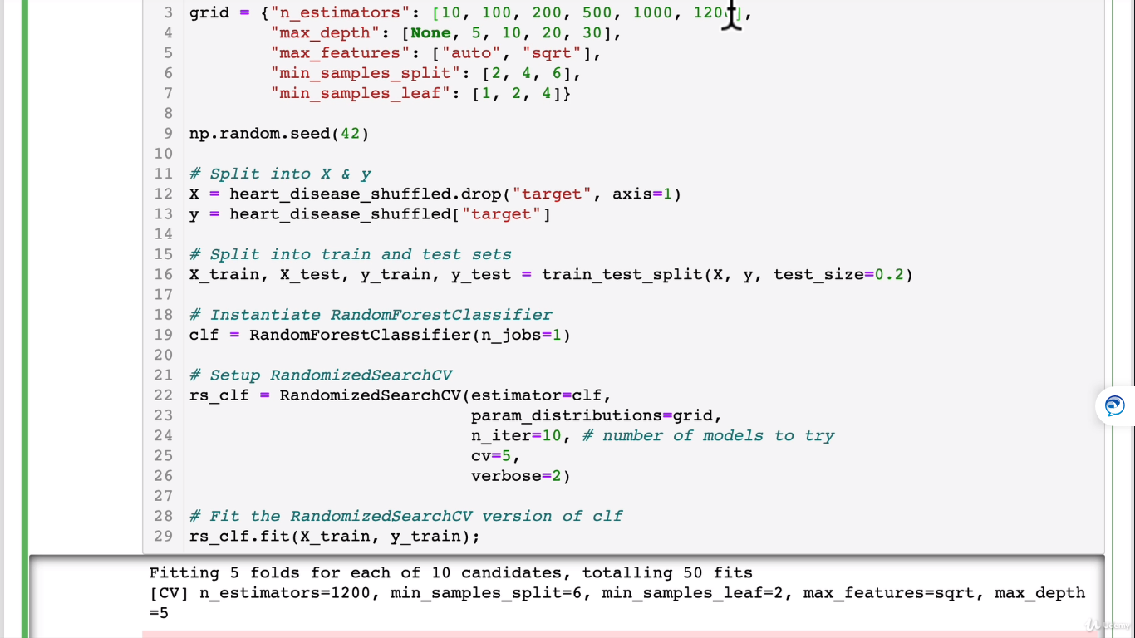

Best parameter combination hyperparameters: This will give yoyu you the best result.

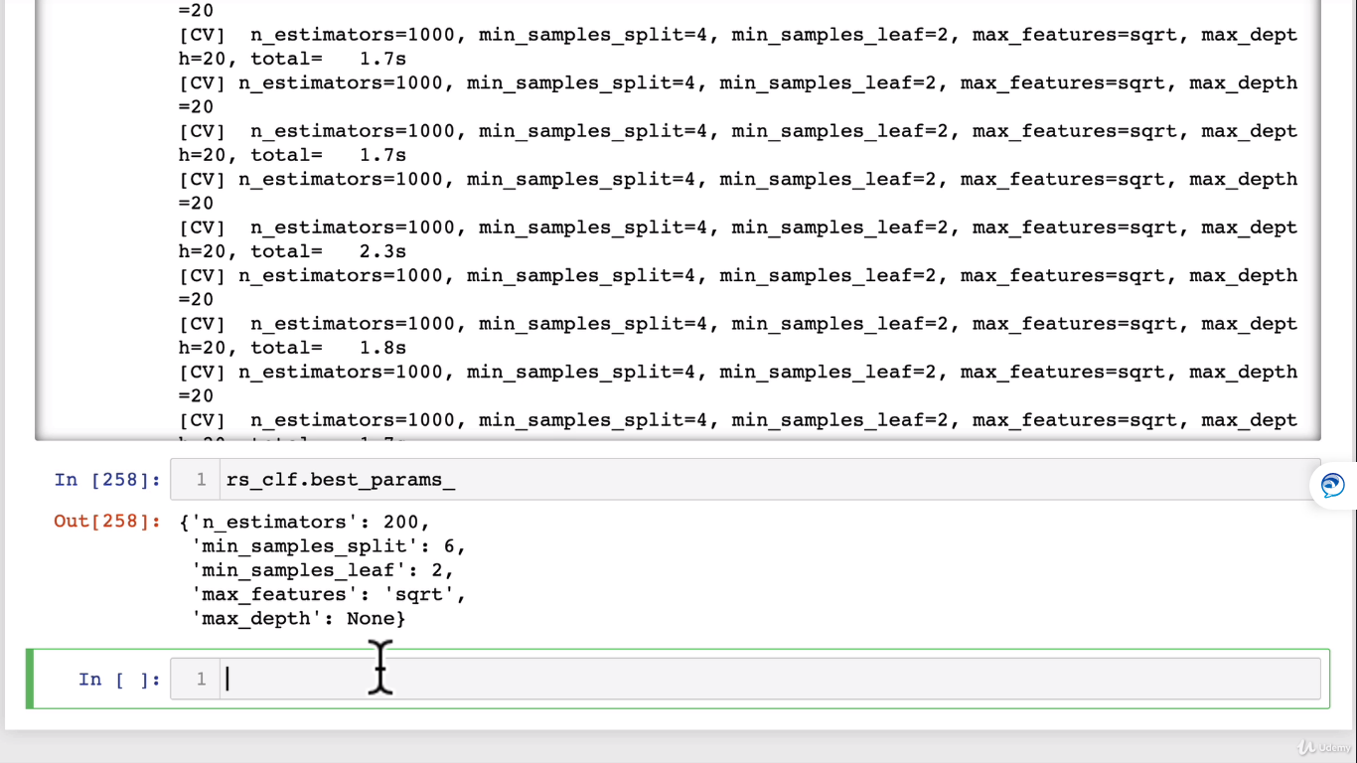

**GritSearchCV:**

It is a brute force search meaning it will go through all combination of parameters given compared to randomized search where we give the search parameter by n_iter =10 meaning it will try to fit only 10 different models.

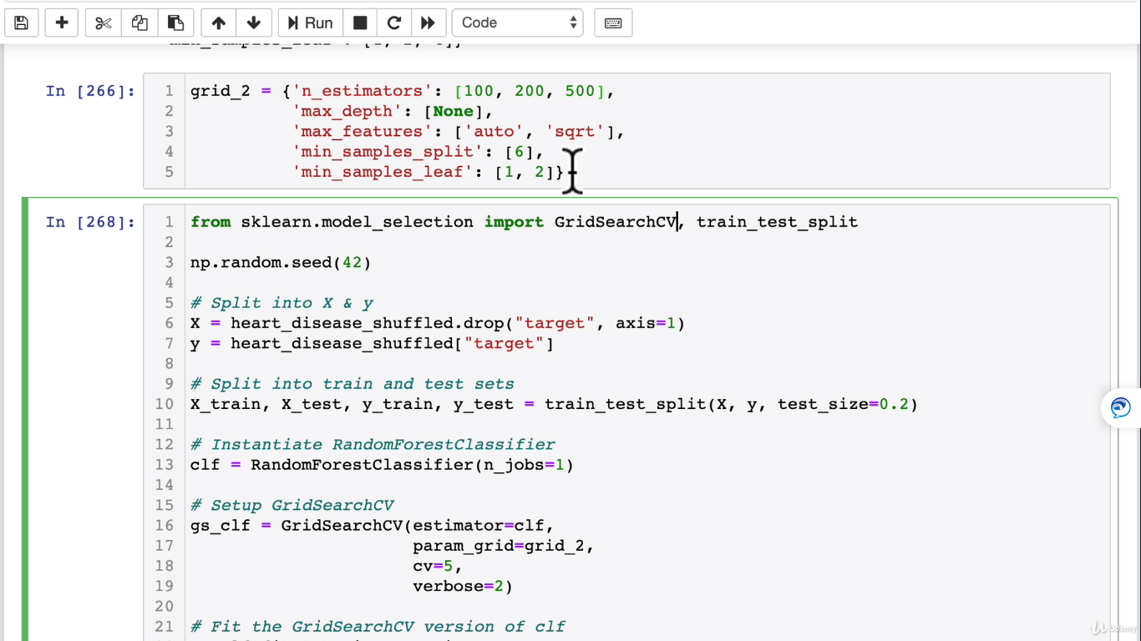

It will go through all the parameters in the grid.

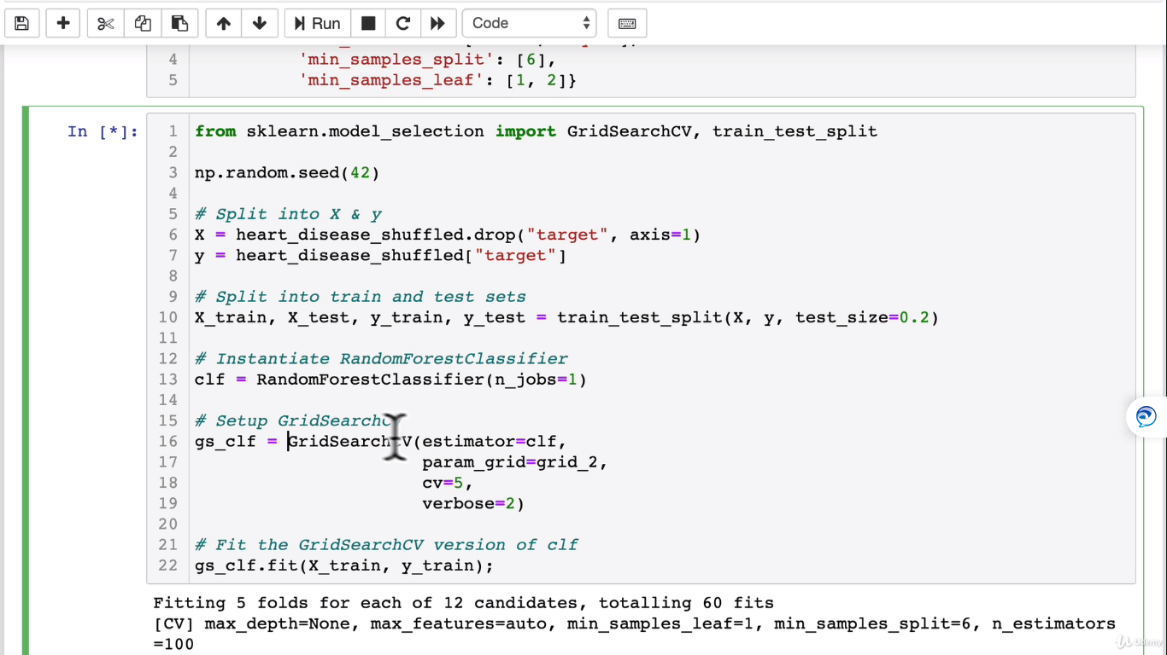

**Now, Best params:**

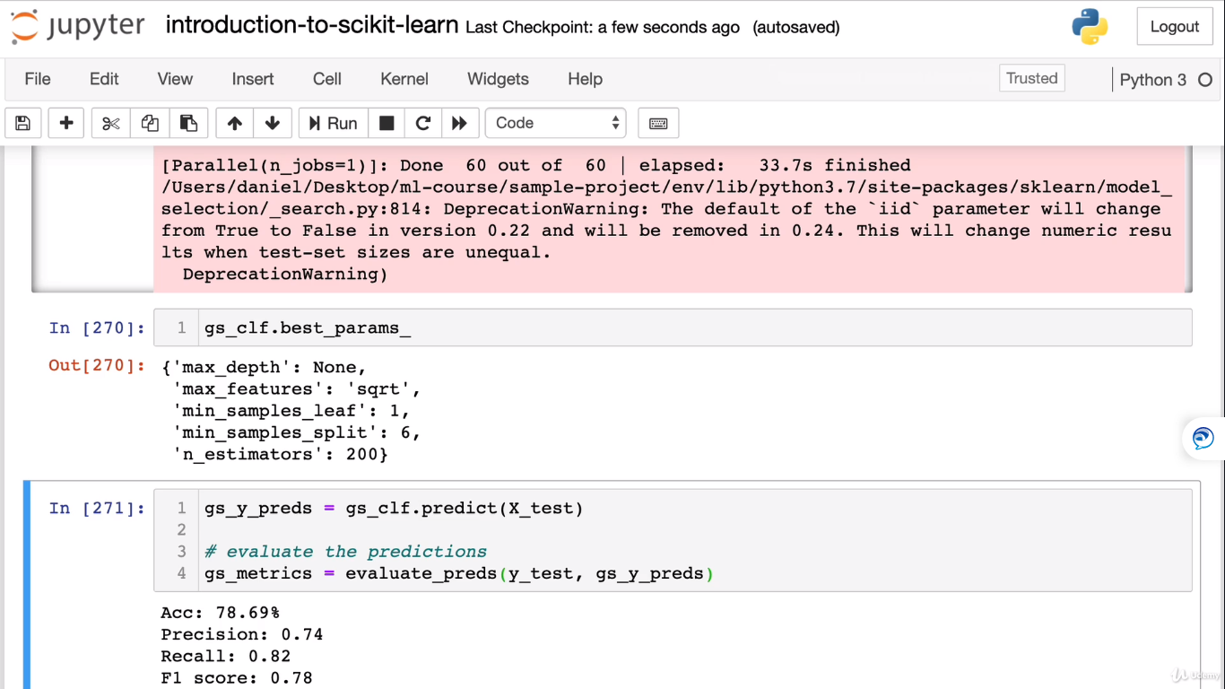

Now lets’c omapre the metrics:

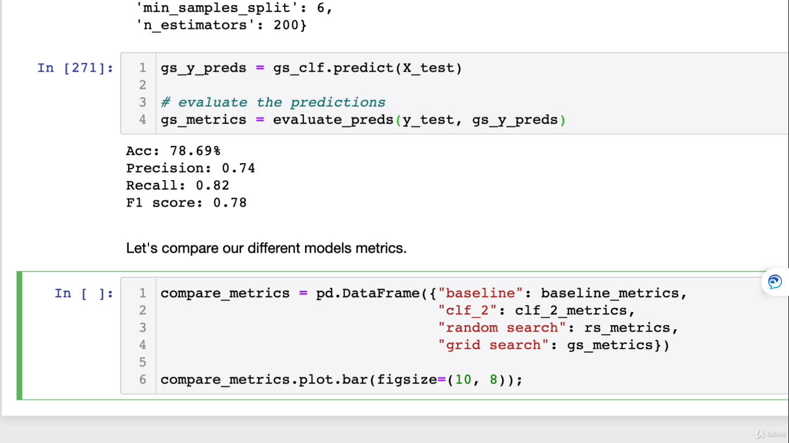

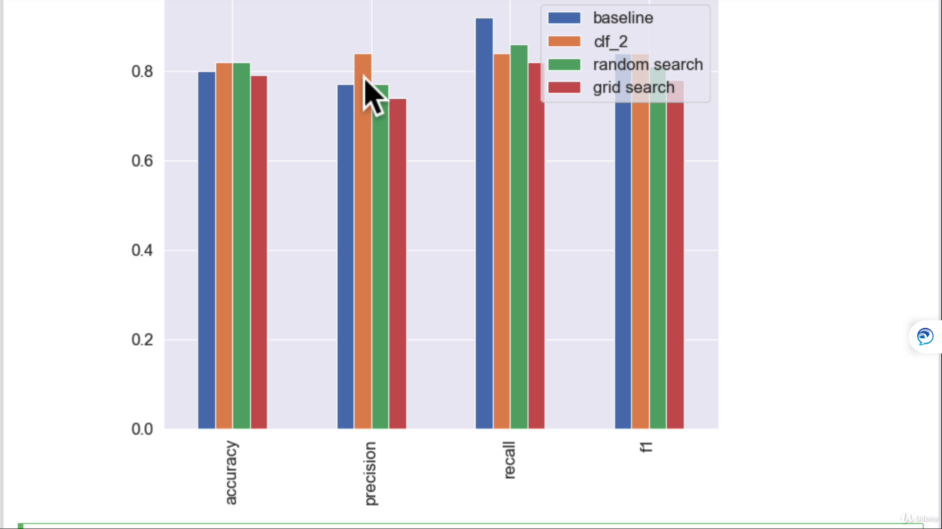

**Correlation_Analysis:**

**Save and Load the model:**

Import pickle

Pickle.dump(gs_clf,open(“file_name.pkl”,”wb”)

Load a saved model:

Loaded_pickle_model = pickle.load(open(“file_name.pkl”,”rb”)

#make some predictions

Pickle_y_preds = loaded_pickle_model.predict(X_test)

Evaluate_preds(Y_test,pickle_Y_preds)

**We can do the same using joblib module:**

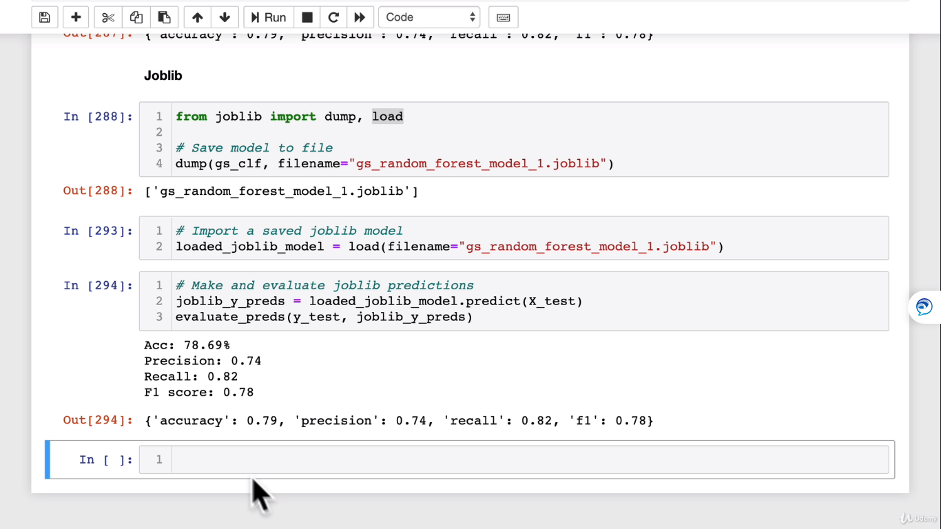

**Final Project**

**To detect car price based on car’s metadata.**

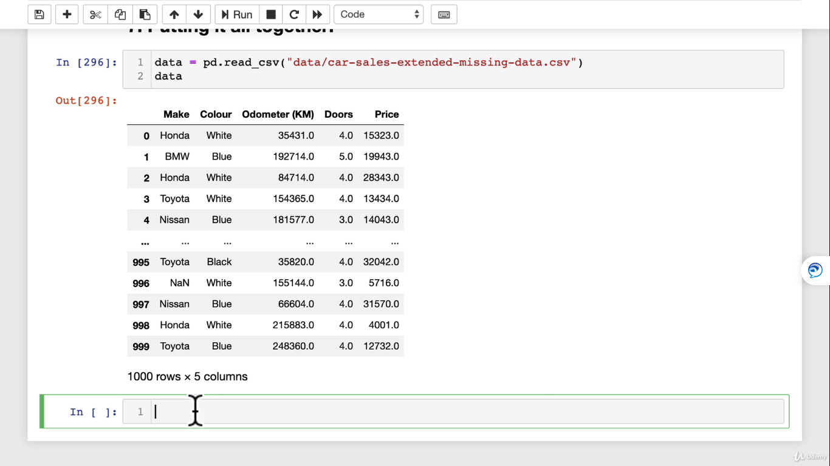

**#Getting Data Ready**

data = pd.read.csv(“car_file.csv”)

data 🡪 TO see the data

data.dtypes 🡪 Make sure all data inputs are numerical

data.isna().sum() 🡪 Make sure there are no nulls

import pandas as pd

import from sklearn.compose import ColumnTransformer

import from sklearn.pipeline import pipeline

import from sklearn.impute import SimpleImputer(This will remove nulls)

import from sklearn.preprocessing import OneHotEncoder(convert data to numbers)

**#now let’s model the data**

from sklearn.ensemble import RandomForestRegressor

from sklearn.model_selection import train_test_split , GridSearchCV

**#setup random seed**

import numpy as np

np.random.seed(42)

**#Import data and drop rows with missing labels**

data = pd.read.csv(“car_file.csv”)

data.dropna(subset=[“price”],inplace=True]

**#Define different features and transformer pipelines**

categorical_features = [“Make”, “Colour”]

categorical_transformer = Pipeline(steps=[

(“imputer”, SimpleImputer(strategy=”constant”, fill_value=”missing”)),

(“onehot”, OneHotEncoder(handle_unknown=”ignore”))])

door_feature = [“Doors”]

door_transformer = Pipeline(steps=[

(“imputer”, SimpleImputer(strategy=”constant”, fill_value=”4))])

numeric_features = [“Odometer (KM)”]

numeric_transformer = Pipeline(steps=[

(“imputer”, SimpleImputer(strategy=”mean”))])

**#setup preprocessing steps(fill miss values, then convert to numbers)**

preprocessor = ColumnTransformer(

transformers=[

(“cat”, categorical_transformer, categorical_features),(cat🡪short form of categorical)

(“door”, doorl_transformer, door_feature),

(“num”, numeric_transformer, numeric_feature)

])

**#creating a preprocessing and modelling pipeline.**

model = Pipeline(steps=[(“preprocessor”,preprocessor),

(“model”, RandomForestRegressor())

]) ( this pipeline is processing in steps of above)

**# Split the Data**

X = data.drop(“price” , axis = 1)

Y = data[“Price”]

X_train,X_test,y_train,y_test = train_test_split(X,y, test_size=0.2)

**# Fit and Score the model**

model.fit(X_train,y_train)

model.score(X_test,y_test)

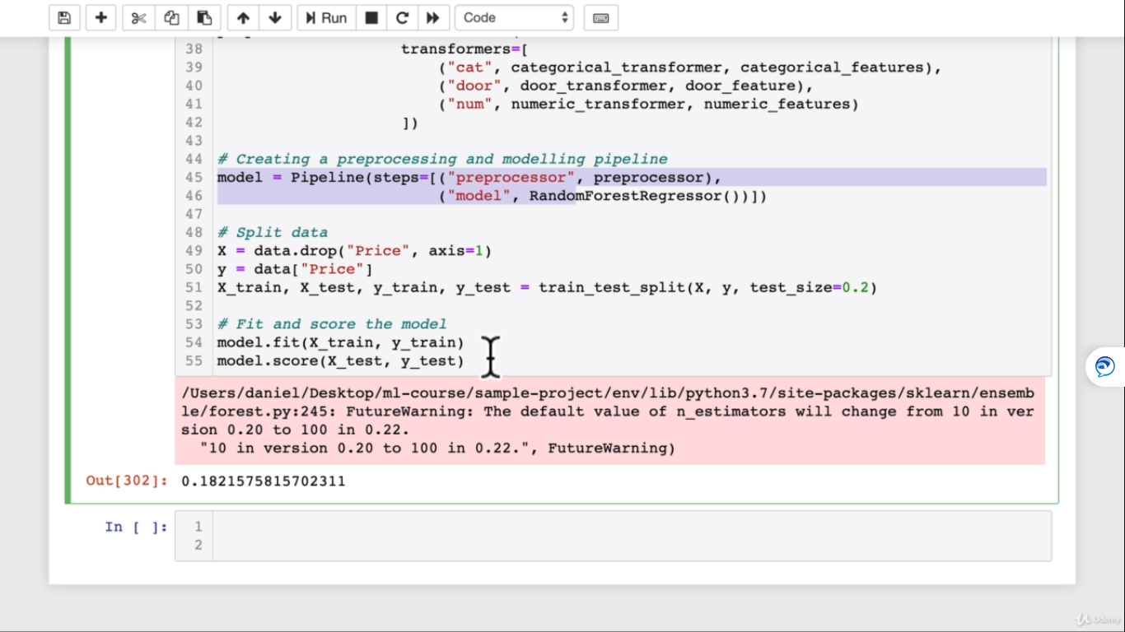

**Now we need to improve the score.**

**It’s also possible to use GridSearchCV or RandomizedCV with our pipeline**

**#use GridsearchCV with our regression pipeline**

from sklearn.model_selection import GridSearchCV

pipe_grid = {

“preprocessor__num__imputer__strategy” : [ “mean”, “median”],

“model__n_estimators” : [100,1000],

“model__max_depth” : [ None,5],

“model__max_features” : [ “auto”],

“model__min_samples_split” : [ 2,4]

}

gs_model = GridSearchCV(model,pipe_grid, cv=5 , verbose=2)

gs_model.fit(X_train,y_train)

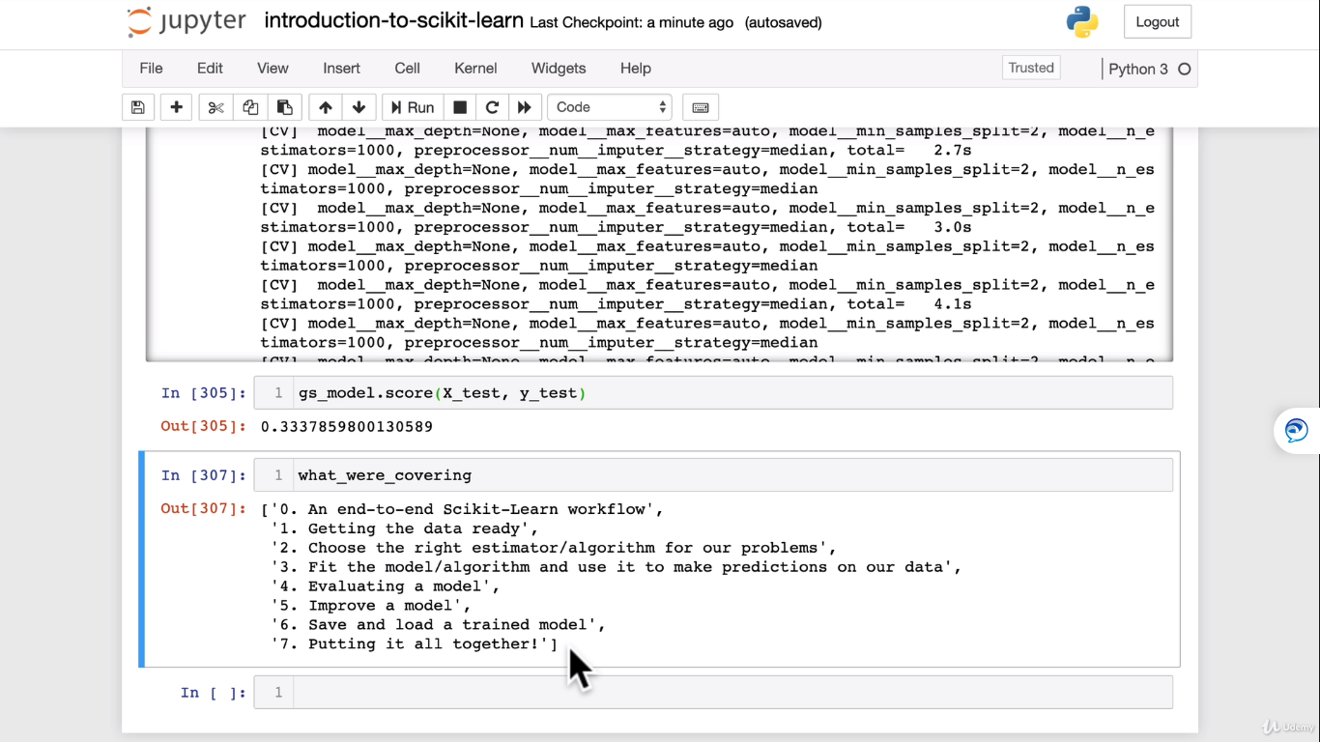

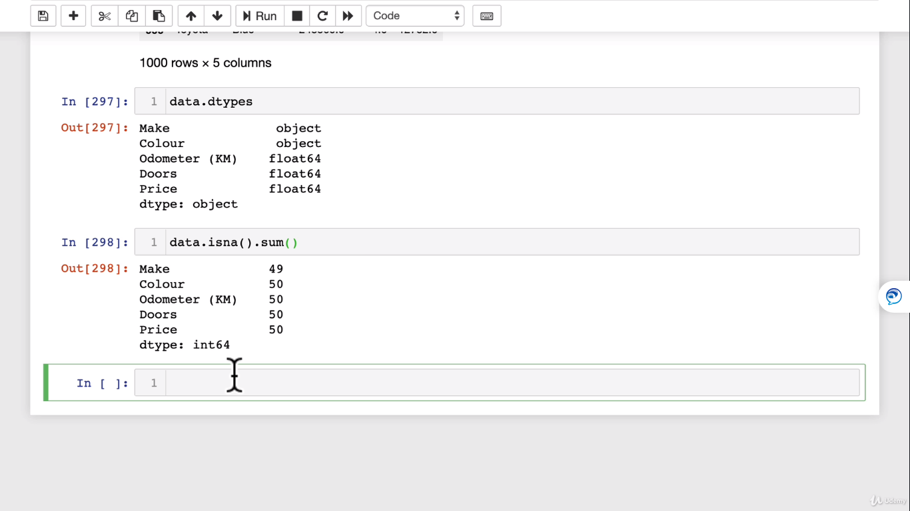

**End to End project on Machine learning:**

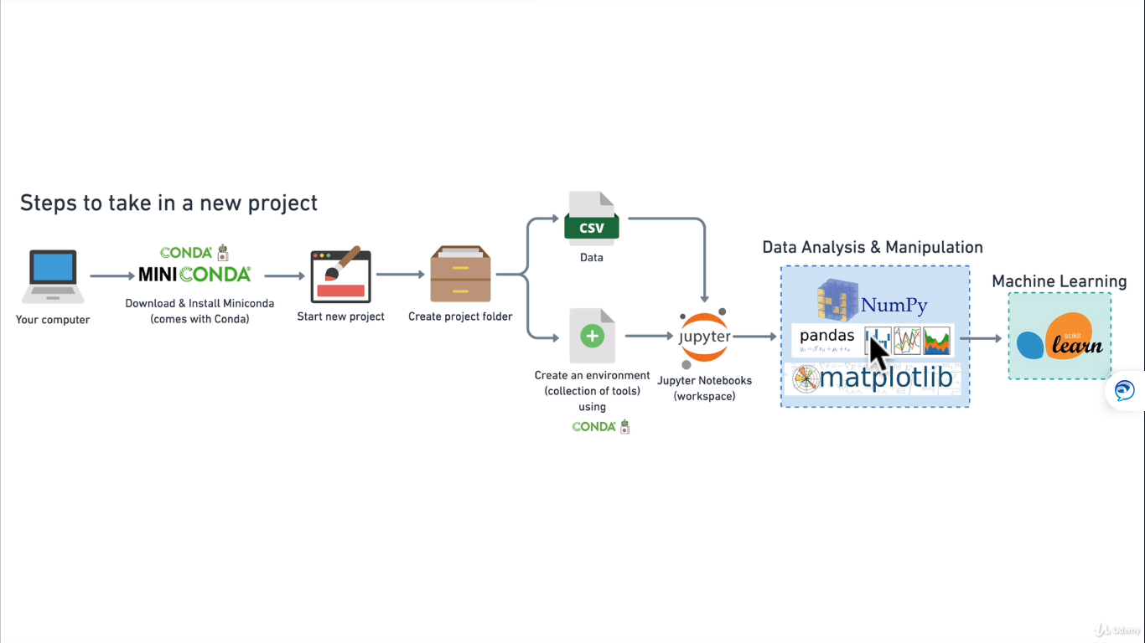

**Lets setup the environment:**

**Lets create new project named “heart-disease-project”**

**In your miniconda prompt:**

Conda env create –prefix ./env pandas matplotlib scikit-learn numpy jupyter

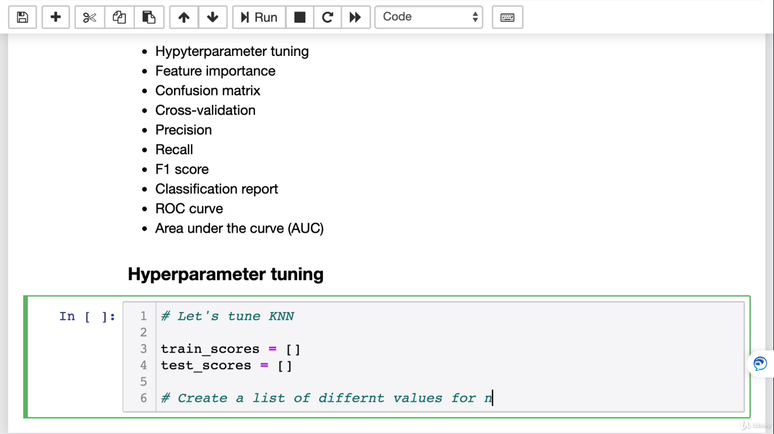

**Convert strings to categories:**

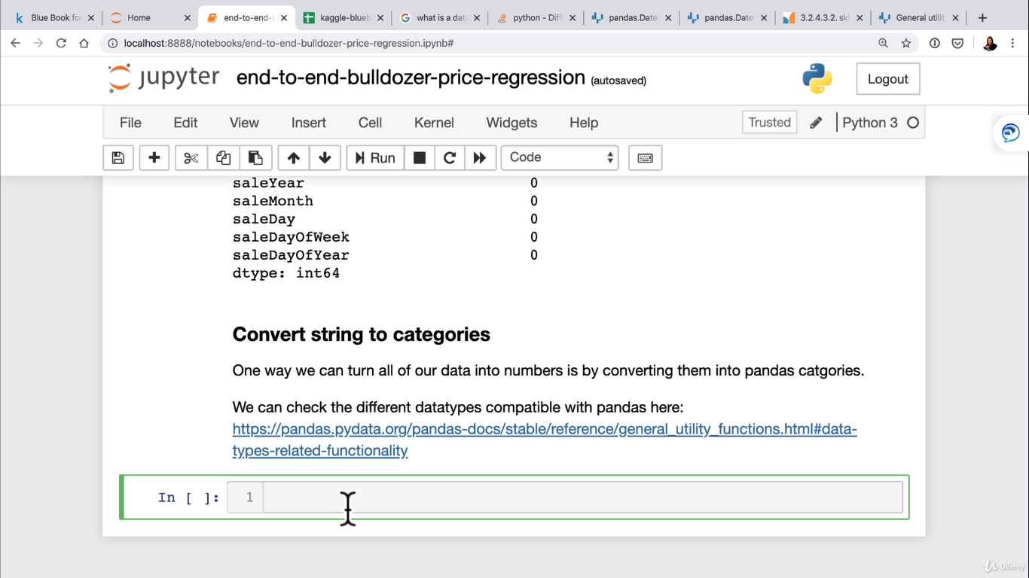

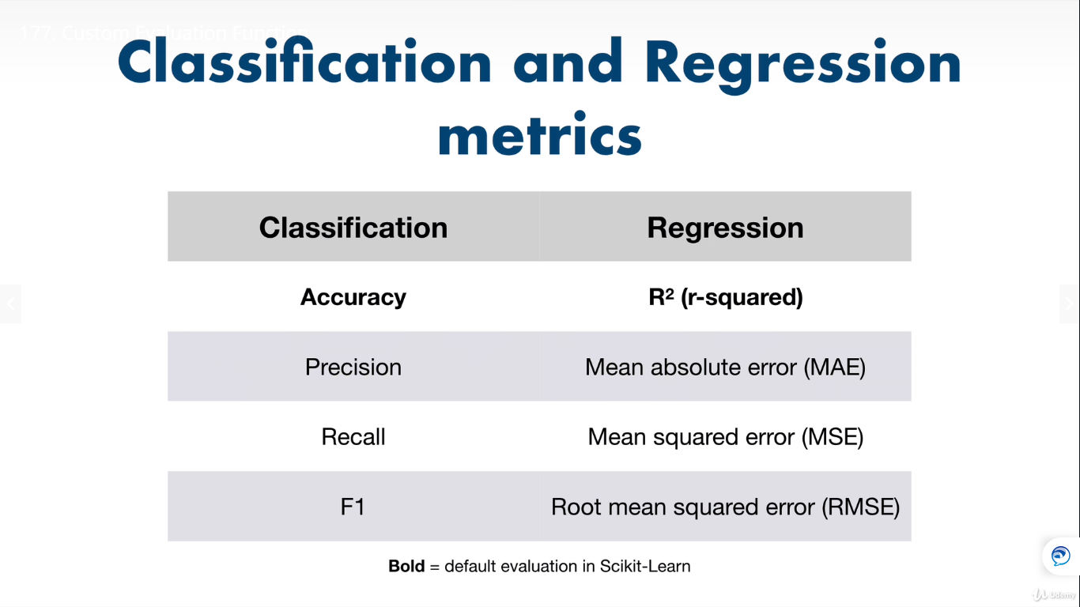

**Data Engineering:**

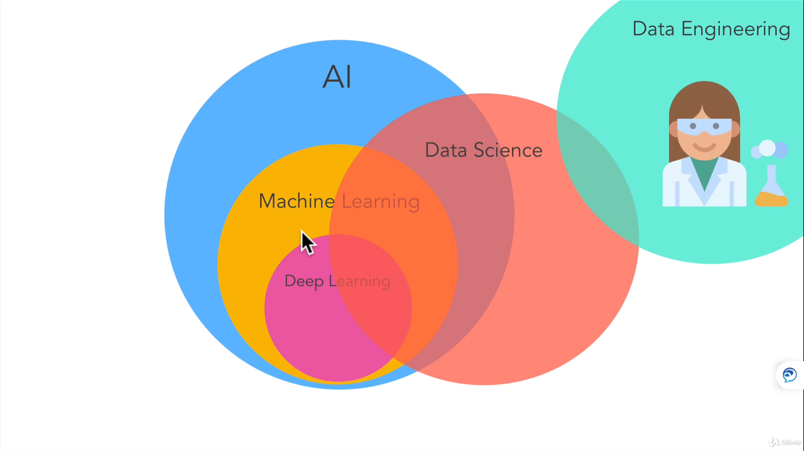

Businesses need to consume these types of data:

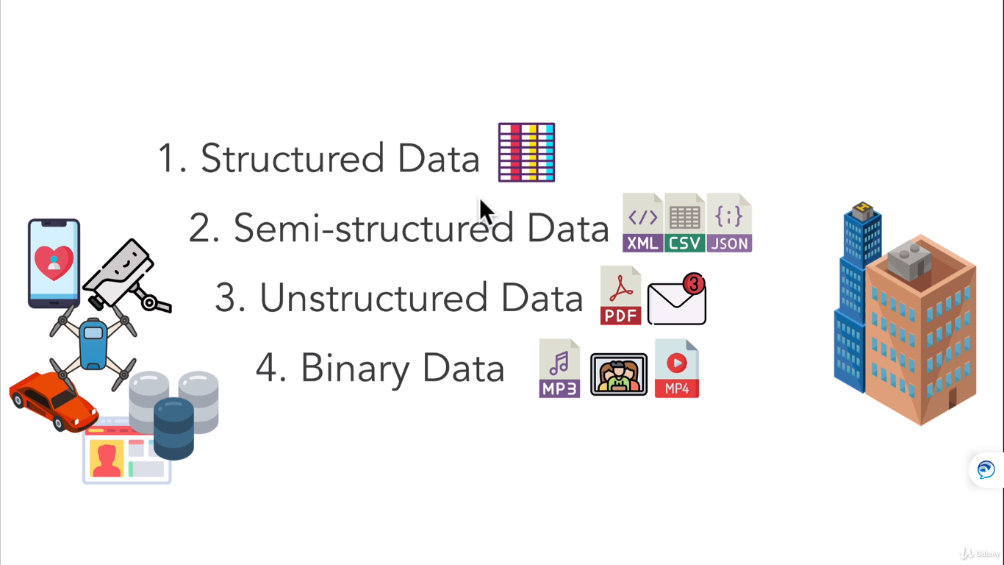

Data Source and Targets:

